# IMAGE CLASSIFICATION USING MACHINE LEARNING

# ABSTRACT

We live in the era of data. We now have huge volumes of data being generated. Differing in form, data could be speech, text, image, or a mix of any of these. In the form of photos or videos, images make up for a significant share of global data creation. In data analysis, image classification is a valuable tool for extracting insights from visual data, automating tasks that require visual recognition, and making data-driven decisions based on image content. It plays a pivotal role in industries ranging from healthcare and agriculture to retail and security, enhancing our ability to harness information from the visual world.

Image classification is a fundamental task in computer vision with widespread applications, ranging from medical diagnosis and autonomous vehicles to content recommendation and security systems. This project aims to explore and implement machine learning techniques for image classification. This exploration proceeds with acquisition and pre-processing of a diverse dataset of images, ensuring data quality and integrity. Applying machine learning algorithms, employed and compared for their performance in classifying images into predefined categories. The findings and outcomes of this project contribute to the advancement of image classification techniques using machine learning and provide practical insights into selecting appropriate algorithms and methodologies for various image classification tasks. Additionally, the project serves as a foundation for further research and applications in computer vision and pattern recognition domains.

Key Terms: Image, Machine Learning, Image Classification, Data Analysis, Digital Image Analysis, Artificial Intelligence, Random Forest, K Nearest Neighbors, Convolutional Neural Network (CNN).

# TABLE OF CONTENT

Table of Contents

IMAGE CLASSIFICATION USING MACHINE LEARNING 1

DECLARATION 2

CERTIFICATION 3

DEDICATION 4

ACKNOWLEDGEMENTS 5

ABSTRACT 6

TABLE OF CONTENT 7

CHAPTER ONE 9

Introduction 9

1.1. Background of the Study 9

1.2. Problem Statement 12

1.3. Research Questions 12

1.4. Aims and Objectives 12

1.5. Motivation of the Study 13

1.6. Significance of the Study 13

1.7. Scope of the Study 14

1.8. Study’s Expected Outcome 14

1.9. Organization of the Dissertation 14

1.10. Definition Of Terms 15

CHAPTER TWO 16

LITERATURE REVIEW 16

2.1. Introduction 16

2.2. Image Analysis and Its Essence Across Industries 17

2.3. Machine Learning as an Emerging Technology 19

2.4. The Science of Image Classification 21

2.4.1. Unsupervised learning 22

2.4.2. Supervised learning 22

2.5. Exploration of Machine learning Algorithms for Image Classification 26

2.6. Research From Related Works 29

2.7. Research Gap 31

2.8. Summary of Related Works and Research 32

CHAPTER THREE: RESEARCH DESIGN AND METHODOLOGY 36

3.0. Introduction 36

3.1. Research Design 36

3.1.1 Empirical Study 39

3.1.2 Mixed Methods Research 42

3.1.2.2 Qualitative Research Approach 43

3.2. Population of the Study 43

3.3. Sample and Sampling Procedure 44

3.4. Method of Data Collection 44

3.5. Data Analysis Method 45

CHAPTER FOUR: ANALYSIS OF DATA AND DISCUSSION 47

4.0. Introduction 47

4.1. Overview of Data Collection 47

4.1.1 Research Instruments 48

4.1.2 Reliability and Validity of Instruments 48

4.2. Data Analysis 49

4.2.1 Research Question 1 52

4.2.2 Research Question 2 53

4.2.3 Research Question 3 54

4.2.4 Research Question 4 & 5 55

4.2.5 Research Question 6 55

4.3. Discussion 56

4.4. Technologies Implemented 62

CHAPTER FIVE: SUMMARY AND CONCLUSION 63

5.1. Introduction 63

5.2. Summary 63

5.3. Findings of the Study 64

5.3.1. Limitations of the study 65

5.4. Constitution to Knowledge 65

5.5. Recommendations 65

References 66

APPENDIX 70

Appendix A: Value of Image Data and Source 71

# CHAPTER ONE

## Introduction

## Background of the Study

The need for data in this rapidly evolving technological world is currently experiencing an exponential increase. Real data is a reliable source and bank for a lot of decision-making processes surrounding a large majority of industries in this age of technology. This data is collected from different sources and these sources could be textual, audio or visual, from these different source types, analysis is conducted, inferences are drawn, predictions are formed and prescriptions are prescribed, each data source type with a different approach of how data is analysed. Most common data sources are text and audio types, visual data types are usually transcribed to text or audio for processing but as the level of technology advances, avenues to handle visual data like static visual data such as images have become an existing technology, the digital analysis of images hence is a process of collecting and understanding data from images; this data is collected, analysed and understood through varying techniques, one of which is image classification.

The need for digital image analysis stems from a necessity for improvement on pictorial information for human interpretation and accuracy. For many reasons applicable to a variety of industries, the need to extract data from images is as important as the need to analyse text or audio data for research purposes, if not greater. Images are essential in all sorts of fields, from the medical field to the agricultural field, to video processing to pathology, pattern recognition, remote sensing, forensics, ecommerce, production, data analysis fields, etc. These fields are sensitive and necessary hence there exists a great need for image analysis. The methods of digital image analysis thus matter to a large extent and require the most updated techniques and modus operandi in other to achieve accuracy for implementation. The crux of the entire process of digital image processing is automation, it is established that a need for image processing exists, for extraction of data to be applied across various fields, for decision making processes with different levels of severity, thus the easier the image analysis, the faster and simpler the entire process, the less the vulnerability chances to errors where the process is automated, the easier complexity is handled and results are created.

Data analysis is an integral part of the world, for data is everywhere around us and even in images, these days, new data kinds are available for data analysis and categorization due to the widespread use of smartphones, tablets, PCs, and other multipurpose devices with high-speed Internet connection. Instead of rating things, it is now possible to gather photos, videos, or music. If a marketing researcher had the right software and algorithms, they could easily categorize or group respondents based on the submitted photos, videos, or music. (Baier, D. et, 2012). Over the years, data collection have shown benefits across all industries, it is literally a door way to the future and a window to the past, the insight data provides to a system’s operational performance cannot be overlooked and for every possible way to harness this insight that exists, proper advantage should be made of such opening, thus there is a constant need to get insight to more streams of data for any industry and visuals such as images make up one of such data streams. With the advancement of technology, there exists modern algorithms and techniques birthed with machine learning that provides deeper insight to the kind of data that can be harnessed from images.

This study is aimed at spotlighting the expedience of machine learning as a tool for digital image analysis specifically image classification. Machine Learning as a digital image data analysis tool has progressively contributed to a lot of industries. The increasing adoption of digital microbiology in clinical laboratories presents a chance to use software for picture interpretation. Expert rules and human-curated information can be used in software analysis tools, but newer artificial intelligence (AI) techniques like machine learning (ML) are being included into clinical microbiology practices. The use of these image analysis artificial intelligence (IAAI) techniques in ordinary clinical microbiology practice is starting, and it will only increase in scope and impact. (Burns, B.L et al, 2023). Burns B.L et al already highlights the transformative influence of machine learning in image analysis in the field of microbiology.

Utilising modern machine learning tools for image analysis creates the expedient process of automation that digital image processing should provide; hence the essence of this research paper is to further highlight how machine learning as a 21st century AI tool largely improves the image analysis sector for all industries. One of the most popular types of data analysis in science, technology, engineering, and business nowadays is image-based machine learning. The ability of these techniques to quickly and automatically extract rich contextual and spatial information from images—a task that has traditionally required a significant amount of human labour—makes them extremely potent. Numerous recent scientific applications have shown how these techniques have the potential to alter how ocean researchers conduct their research. But in many sectors, machine learning methods remain underutilized despite their potential. (Belcher, B.T et al., 2023). The purpose of image analysis is to condense large-scale visual data into much more manageable summaries that are pertinent to a certain job or research goal. This kind of visual data reduction comes naturally to humans (Marr, 2018). When we examine a picture, we can identify what is there, locate and count individual items, and divide the image into several types of regions with the right training. The goal of computer vision's image-based machine learning (ML) area is to teach computer algorithms to carry out these similar tasks accurately. According to Norouzzadeh et al. (2018), doing so can significantly speed up and lower the cost of image processing while also supplying a clear, consistent, and repeatable workflow that can be shared easily among researchers and applied to new problems. (Godwin et al., 2012; Katiia et al., 2022).

## Problem Statement

Applications for image classification are found in numerous fields, including machine vision, traffic control systems, medical imaging, object recognition in satellite photos, and more. Image classification forms the basis for solution to a lot of vision related problems and this cuts across a lot of industries. Tools to automate the process of digital image analysis in previous times was nothing more than human reliability, requiring a lot of labour and effort, but in recent times, with the evolution of Artificial Intelligence (AI), Machine Learning (ML) has become a pivotal technique in handling image analysis problems, but somehow this technique is under exploited. Thus, this research aims to shed light on ML and by extension increase the exploitation level of the technique for image analysis processes, specifically image classification.

## Research Questions

The research will attempt to answer the following questions:

1. What is Image Classification?
2. What is the importance of Digital Image Analysis?
3. What is Machine Learning?
4. How can Machine Learning be exploited to Improve Digital Image Analysis?
5. How can Image Classification be done using ML?
6. Does Image Classification using ML improve Image Data Analysis?

## Aims and Objectives

The aim of this study is to shed light on the need to exploit Machine Learning as a tool for digital image analysis using ML on Image Classification as specifics to show how this improves digital image analysis across industries.

The objectives of the research are:

1. To highlight Image Classification, Digital Image Analysis and Machine Learning.
2. To highlight the problem with under exploitation of Machine Learning as a tool for digital image analysis
3. To understand and establish the need for digital image analysis across industries
4. To identify how ML improves the image data analysis process
5. To sample ML techniques on an Image classification problem to practically show how Image Classification using ML can be conducted.

## Motivation of the Study

Data Analysis is a rapidly growing sect, but you’d find that a large extent of attention and focus is settled on textual and audio data, of course visual data is analysed and inferences derived from this analysis but the margin between the data types appears to be significant and the need to analyse image and visual data appears to be on an increase with the evolution and creation of different industries and new technologies such as the medical field, the agricultural field, biotechnology fields, microbiology fields, oceanography fields, satellite and weather related fields as well, etc. In Nigeria, these fields are not explored to a broad span and the analysis of digital images is not a very common practice in the industries thus the field is underexploited even with the existence of new technologies worldwide, hence the need to shed light on ML technology and create a practical contribution to how this technology can be exploited to improve data analysis across industries.

## Significance of the Study

This research has both theoretical and practical significance:

Theoretically, this study adds to existing works and literature on Machine Learning as well as Digital Image Analysis and Image Classification and becomes a source for other researchers, the step-by-step practical process to conducting Image Classification provided within this thesis becomes a guide to digital image analysis for practical purposes.

Practically, this paper becomes a data bank to students, researchers and data analysts across the world and would be useful to different industries involving image identification, classification and research. This could potentially lead to an increase in exploitation of the ML technology on Digital Image Analysis projects.

## Scope of the Study

The scope of this research is limited to shedding light on the concept of Machine Learning as an AI technology that could be utilised and exploited for different reasons across different. The implementation of this need to show how ML can be exploited for Digital Image Analysis would involve practical documentation of the Image Classification process using Machine Learning.

## Study’s Expected Outcome

1. At the end of this study, a complete documentation sampling Machine Learning techniques applied on an Image Classification problem is to be developed.
2. A comprehensive study composed of similar existing literatures reviewed for this research in order to reinforce the study’s aims and objectives.
3. A working Image Classification model to reinforce the need to exploit ML as an emerging technology.

## Organization of the Dissertation

Chapter one of this research is the introductory section of this study dedicated to providing a rationale for the study, showing why the research is relevant and what problem exists that warrants the study. This chapter also features the background of the study as well as the research problem and objectives of this research, stating the aims and goals of this research on its completion and also posing the relevant questions that this research aims to provide answers to. Other parts of the chapter emphasize on the significance of the study and its importance or relevance to others (students, researchers, analysts), the scope of the study and an outline of the entire research in the organization of the project. Summarily, this chapter is a starter pack to the bulk of this research work showing the problem, the need to solve the problem and a brief glance into the how where a solution is concerned.

## Definition Of Terms

Terms used in this chapter and throughout the research: Image, Image Classification, Digital Image Analysis, Data Analysis, Machine Learning, Artificial Intelligence.

1. Image:  An image is a visual representation of something, while a digital image is a binary representation of visual data. These images can take the form of photographs, graphics and individual video frames.
2. Image Classification: Image classification is the process of categorizing and labelling groups of pixels or vectors within an image based on specific rules. It is a supervised Machine Learning problem.
3. Digital Image Analysis: Digital Image Analysis or Computer Image Analysis is the automatic study of an image to obtain useful information from it.
4. Data Analysis: Data analysis is the process of inspecting, cleansing, transforming, and modelling data with the goal of discovering useful information, informing conclusions, and supporting decision-making
5. Machine Learning: Machine learning is a branch of artificial intelligence (AI) and computer science which focuses on the use of data and algorithms to imitate the way that humans learn, gradually improving its accuracy.
6. Artificial Intelligence: Artificial intelligence is the intelligence of machines or software, as opposed to the intelligence of humans or animals. It is also the field of study in computer science that develops and studies intelligent machines.

# CHAPTER TWO

# LITERATURE REVIEW

## Introduction

The entirety of this research is based on the need to familiarize the concept of image classification using Machine Learning as an emerging technology with so much potential already harnessed. It is an explorative work designed to hinge on the idea of image classification as a necessary data analytics facet deigned to reveal so much more details from imagery and pictorial information that could be very useful in optimization of a lot of decision-making processes across several industries. This explorative thesis employs the use of ML algorithms and techniques to show how image classification models can be utilised for decision making and discusses the impact of this across industries and the existing need to embrace this technology in Nigerian solutions.

Understanding data goes a long way in solving problems, this data can be in any physical form, beyond text and numbers, raw data is also visually represented in images. Harnessing this raw data from images is an advanced technology that yields so many answers to many questions across many fields, making analysis and arrival at decision making processes and inferences easier, hence the need for image classification, this could be image recognition or identification or sampling of microscopic factors from wholesome images that could make entire differences in a research process. Utilizing ML as an emerging technology for this process drives at simplifying and optimizing the science of the process of image data extraction and identification using image classification as the basis for this thesis.

## Image Analysis and Its Essence Across Industries

Image processing is a broad term that refers to any manipulation of digital images, such as resizing, cropping, filtering, enhancing, or transforming. Image processing automation is the use of software tools or libraries to perform these tasks automatically, without human intervention.

Across so many diversifying industries, data has been founded to be a necessary player in growth and scalability, for every venture or enterprise, a reliance on data for futuristic inferences, detection of recurring patterns and history and current status has consistently steered processes in the right direction, of course with a number of exceptions. Despite, these exceptions, data analysis and analytics continues to be a window of foresight. In a research paper, where traditional methods of image analysis and modern methods of digital analysis were analysed and reviewed by Selles, M.A et al; a comprehensive study revealed the great applicability of image analysis and the fact that data obtained through it has high reliability when compared with numerical results. (Selles, M.A et al, 2021). This group situated their study in an industrial space applied to metals characterization, in so many industries of diverse dealings, image analysis furthers productivity as it gives a wider data insight as there is a constant need to study the characteristics and properties of elements in different fields more closely, based on available data, it is thought that this technology has not yet reached its full potential and is still experimental in many circumstances. Because of this, scientists working in this area are urged to create a rule that will make it easier to apply the DIC method and increase the viability of comparing the outcomes of this method. In conclusion, it is critical to emphasize the method's broad usefulness in the characterization of metallic materials, particularly in domains where numerical analysis is inadequate for accurately simulating the material's nonlinear behaviour since this approach considers both the actual conditions the material undergoes and the process itself. (Selles, M.A et al, 2021). Across industries, there are phenomena that needs to be captured and analysed and somehow qualified in order to make inferences or assess status, these phenomena possess properties that cannot necessarily be represented in numerical figures as data and if tried may not be a proper representation of the phenomena, image analysis allows to capture in-depth these non-linear properties. Selles et al believes the space of image analysis as at 2021 to be underexplored which is one of the propelling reasons for this thesis.

Image analysis as a way of data extraction and insight is not merely the human eye capturing pieces of imagery in order to make inferences and decisions. The most vital sense that enables a person to see his environment is sight. The human eye and brain can quickly identify the size, shape, structure, and colour of the things under examination while also confirming that they match the norm. Perception of the observer limits the interpretation of pictures captured by sight alone. The growing quantity of items and their movement made it more difficult to properly interpret human observations. Additionally, the eyes are tired quite fast, thus their ability to differentiate selected features of the object decreases. (Jelinski, T. et al, 2012). Jelinski in his research points out a well-known factor that the human eye is not the most reliable extractor of information from photographs, but of course practice over the years in many fields has seen professionals take up the roles of scanners to decipher information from imagery. This role has changed over time with digital image analysis and this is common in so many industries, from the medical space to the crime scene, etc. With the development of electronic engineering, optics and computer techniques, the possibility of replacing the eye with digitally computed systems became a reality. In audio-visual applications, new technologies for signal processing and registration are probably being developed. Processing of images produced by visible, infrared, and ultraviolet radiation, ultrasounds, X-rays, and electron beams is made possible by applying the proper converter to the signal. Processing these kinds of photos is sometimes referred to as "image analysis," and it yields the procedures involved in processing and registering any data pertaining to the thing being observed. (Wojnar, 1994). (Jelinski, T. et al, 2012). The whole image analysis process for every industry is in phases, and depending on the delicacy of analysis and nature of the field, keenness is attached to the process. The set used for image analysis as presented by Jelinski et al is divided into three modules, which include: Acquisition, Processing and analysis of image and finally Analysis of obtained results. Image acquisition begins by a conversion module from an analogue to digital form and processing and analysis of images proceeds in a program module supported by sophisticated software for improvement of image quality and extraction of image details which is very important in further analysis. The final analysis result which is an analysis of extracted details is often conducted with external computational statistical-mathematical software.

The continuous advancement in digital image analysis opens up new avenues for the application of visual computer systems for agricultural material estimate, including food sector materials. (Lewinski, 1995; Wiwart, 1999). A good example defined in Jelinksi et al, 2012 was the classification of grains based on detection of the object’s edge (kernels, seeds, impurities), segmentation or shape analysis and look of object surface. Application of visual computer systems were forecast to be used in the food industry for monitoring and steering of technological processes in cereal grain processing. The application of digital image analysis in the food and entire agriculture industry for identification and classification of crop and food varieties is a common practice that is attributed as important on a large scale for its automation, its application is widely explored for milling yield prediction, for grain identification, for flour quality evaluation, bread structure, pasta quality, food microstructure, microbial recognition, etc.

Across industries, image processing, from recognition to analysis, once automated can be a great time, money and resources saver by improving quality and consistency, reducing manual work and enabling new possibilities and capabilities. The analyzation of images for information or insights by extracting features, detecting objects or recognition is the superpower, image data analysis provides. This is evident across different industries including but not limited to e-commerce and retail, healthcare and medical, media and entertainment, agriculture, construction, finance, crime, etc.

## Machine Learning as an Emerging Technology

Machine learning, or ML, is the fusion of multiple scientific and technical fields. Although machine learning is conceptually inside computer science, it primarily draws from other traditional subjects such as statistics, computational algorithms, optimization, and data mining, as well as from established computing ideas and technology. In 2018, Kiadi, M. and Tan, Q. Fundamentally, machine learning assesses the relationship between inputs and outputs in order to determine which mathematical model is most appropriate. This is the function that maps input data to its equivalent outputs with the fewest errors possible; if such a function is identified, it may be used to predict an unknown output given a given input; this process is known as predictive analysis, and machine learning (ML) has well-established techniques for it. Finding the relationship between inputs and anticipated outputs allows those techniques to identify patterns in the data that already exists. In 2018, Kiadi, M. and Tan, Q. In a paper, Kiadi and Tan examine machine learning (ML) as a concept and all the fields of new technology, briefly touching on deep learning, data science, arithmetic, and statistics. They also analyse the space opened up with ML as a technology and discuss the possible implementations, the duo further branches out to some of the different ML algorithms and techniques and provide insight to the field, they identify an ML mind map revealing some of the most practical techniques in ML, one or two of which we will focus on proper in the course of this paper, as this study is hinged on the use of Machine Learning.

There are a gazillion methods and potential applications for applying machine learning to solve issues. Ang, K.L. et al.'s 2022 study, which focuses on the development of new technologies for smart cities, identifies a number of developing technological domains, such as data analytics and geo-information. Among these fields, machine learning is particularly noteworthy. In data science modelling and analytics, machine learning is used to extract trends and patterns from data. Machine learning algorithms can be broadly classified into three types: (1) reinforcement learning algorithms; (2) unsupervised learning algorithms; and (3) supervised learning methods. Neural networks (NN) are a popular supervised learning technique for regression and classification. Labelled data is required for supervised learning algorithms to function. Numerous smart transportation applications, such as traffic flow prediction, parking space forecasting, transportation trip route evaluation, and bus arrival time prediction, have made use of unsupervised learning techniques. Labelled data is not necessary for these procedures. A recent advancement is the emergence of deep learning (DL) models.is a new development in contemporary machine learning algorithms. Some examples of deep learning models are convolutional neural networks (CNNs), recurrent neural networks, deep reinforcement learning models, deep restricted Boltzmann machines, stacking auto-encoders, etc. A survey on deep reinforcement learning for intelligent transportation systems is available. Among the applications are traffic flow density prediction, vehicle detection, and traffic data imputation. This study centres on novel artificial intelligence approaches for traffic modelling and prediction, traffic control and management, mobility and transportation, public transit, and other relevant applications for self-ceasing cars. (Kiadi, M. & Tan, Q., 2018). In their study, the Kiadi-Tan duo expatiate on how the emerging technology is harnessed and break it down into bits, for the purpose of this study to explore image classification using ML, we explore the supervised ML technique.

As continuously leveraged in this study, the versatility of ML as emerging technology is what has made the science extremely popular and widely spread, the possibility of implementation across so many diverse fields. Philip Jestine analyses the perspective of embracing emerging technologies for organizational behaviour, this is yet another diverse and outstanding angle in the sea of its implementation. Emerging technologies are capable of enhancing organizational- and individual-level outcomes. The organizational behaviour (OB) field is beginning to pursue opportunities for researching emerging technologies. (Philip, J., 2022). This researcher analyses how organizational behaviour otherwise referred to as OB in her work is majorly theory-driven and deductive, she points out how with the vast amounts of data and enhanced algorithmic capabilities available today, an appropriate balance and integration of theory and data can help reveal the intricate complexities in employee behaviours. She explores this through researching different emerging technologies within the context of Organizational Behaviour such as in decision-making, identity, trust, bias, leadership and so on and further extends to incorporating advanced data analysis techniques in her study.

## The Science of Image Classification

Determining what an image depicts is one of the tasks of computer vision, or picture categorization. It entails importing an image and determining its category by applying a certain classification technique. picture classification is the process of categorizing and labeling subsets of pixels or vectors within a picture according to predetermined standards. The categorization law can be used with one or more textural or spectral characterizations. Boesch, G. (2023). Techniques for classifying images fall into two basic categories: supervised and unsupervised image classification techniques.

## Unsupervised learning

No training data is used in the completely automatic unsupervised classification technique. This means that machine learning algorithms are used to analyze and cluster unlabelled datasets by finding hidden patterns or data groups without the requirement for human intervention. In the image processing phase, a suitable algorithm is used to systematically identify a picture's unique features. Pattern recognition and image clustering are two of the most widely used methods for picture categorization that are utilized in this context. "K-mean" and "ISODATA" are two popular methods for categorizing pictures without supervision. K-means is an unsupervised categorization technique that puts things into k groups based on their characteristics. It is also known as "clusterization." K-means clustering is one of the easiest and most popular unsupervised machine learning algorithms. ISODATA, which stands for "Iterative Self-Organizing Data Analysis Technique," is an unsupervised image classification method. In the ISODATA approach, the Euclidean distance is iteratively utilized as a similarity metric to classify individual data elements into different groups. Unlike k-means, which assumes that the number of clusters is known a priori (ahead of time), the ISODATA technique allows for a varied number of clusters. Boesch, G. (2023).

## Supervised learning

Supervised image classification techniques use previously categorized reference samples, also referred to as the ground truth, to train the classifier to detect new, unknown data. Therefore, the supervised classification technique refers to the process of visually choosing training data samples from the image and allocating them to pre-selected categories—such as vegetation, roads, water resources, and buildings. This is done to produce statistical metrics that may be applied to the full image. (Viso Suite, 2023).

The three primary steps in image classification are classifier design, feature extraction, and picture pre-processing. We live in the information age these days. Images are essential and contain a wealth of information. Finding valuable picture information in an efficient amount of time is crucial for a big number of photographs. Consequently, a few elements that affect the outcome of picture classification are influenced by the algorithm's exceptional performance. (Luo, L., 2021). The idea of image classification as put forward by Luo Lihua in an image classification algorithm-based research, identifies the phenomena to involve the use of a specific classification algorithm to determine an image’s category, this image would be input to the algorithm. Using computational algorithms to extract features from the image in order to fish for information is the base idea of the entire process. Luo hinges his research on a comparative analysis of manual feature extraction of traditional machine learning and the main process of image classification: image pre-processing, image feature extraction and classifier design, he focuses his research on the study of image classification algorithms based on convolutional neural networks, and at the same time, compares and analyses deep belief network algorithms while summarizing the application characteristics of the different algorithms he studies; the similarity in his approach and the approach this study is geared towards is quite clear in the exploration of different algorithms, something that we keenly explore in 2.6.

The difficult process of classifying images can be influenced by a wide range of circumstances. To increase classification accuracy, it is very important to choose an appropriate classification approach and to make efficient use of many aspects of remotely sensed data. (Lu, D. & Weng, Q., 2006). Lu & Weng discuss and analyse practices, problems and prospects of image classification at the time, putting special emphasis on the synthesis of the main advanced classification approaches and the methods employed to increase classification accuracy, they propose that selecting an appropriate classification method and making efficient use of the various features of remotely sensed data are particularly important for increasing classification accuracy. Non-parametric classifiers, including neural networks, decision trees, and knowledge-based classification, are becoming more and more significant methods for classifying data from multiple sources. A new area of research is the integration of expert systems, geographic information systems (GIS), and remote sensing. (Lu, D. & Weng, Q., 2006). However, they conclude just like a good number of other researchers that more research is needed to improve classification accuracy, between the time of their study and the current day, a lot of research in the field has been conducted to bridge this gap of finessing the classification accuracy. They do, however, come to the same conclusion as many other researchers—namely, that in order to close the gap in fine-tuning categorization accuracy, a great deal of research in the subject has been undertaken since the time of their study. A strong classification system and a sufficient number of training samples are necessary for a successful categorization. Cingolani et al. (2004) identified three key challenges when using medium spatial resolution data for vegetation classifications: selecting representative training sites, defining discrete land-cover units distinguishable by selected remote-sensing data, and defining appropriate hierarchical levels for mapping. The user's needs, the geographical resolution of the specific remotely sensed data, and the compatibility with time constraints, previous work, and readily available image processing and classification methods are generally the determining factors. Such a system should be comprehensive, modular, and pedagogical (Jensen 1996, Landgrebe 3003). In many cases, a hierarchical classification system is employed to account for different situations. A significant number of training examples and their representativeness are necessary for image classifications (Hubert-Moy et al. 2001, Chen and Stow, 2002, Landgrebe 2003 Mather 2004). Weng, Q., and Lu, D. (2006). Lu and Weng further dissect the necessities for a successful image classification project and highlight necessary steps, these include: selection of data source, selection of a classification system and training samples, data pre-processing, feature extraction and selection, selection of a suitable classification method, post-classification processing, evaluation of classification performance and classification accuracy assessment.

In order to enable computers to recognize and classify visual content inside images, the multidisciplinary discipline of image classification integrates parts of computer vision, machine learning, and image processing. A basic issue in computer vision, image classification has numerous applications in industries like entertainment, security, healthcare, and self-driving cars. Below is a summary of the main ideas and elements that form the basis of the science of picture classification:

1. Data Acquisition and Pre-processing: The process starts with acquiring a dataset of labelled images, where each image is associated with a specific category or class. Data pre-processing involves tasks like resizing, normalization, and augmentation to ensure that the input images are suitable for analysis. Data quality is critical because the accuracy of image classification models depends on the quality and diversity of the training data.

2. Feature Extraction: In traditional machine learning, feature extraction is a crucial step where relevant information is extracted from the raw image data. Features can include colour histograms, texture descriptors, edge detectors, and more. However, in deep learning approaches, feature extraction is typically learned automatically through convolutional neural networks (CNNs), which excel at capturing hierarchical features from raw pixel values.

3. Model Selection: The choice of the classification model is essential. Popular models for image classification include support vector machines (SVMs), decision trees, k-nearest neighbours (KNN), and, most notably, CNNs. CNNs have revolutionized image classification by outperforming traditional techniques in many tasks due to their ability to learn hierarchical and spatial features.

4. Training and Optimization: Training a classification model involves feeding it with the labelled data and iteratively adjusting its parameters to minimize the classification error. Optimization techniques like gradient descent and backpropagation are commonly used to update model weights. Hyperparameter tuning is also crucial to find the best configuration for the model.

5. Evaluation Metrics: To assess the performance of an image classification model, various evaluation metrics are used, including accuracy, precision, recall, F1-score, and ROC curves. These metrics help quantify the model's ability to correctly classify images into their respective categories.

6. Transfer Learning: In many real-world scenarios, acquiring a large labelled dataset for training a deep learning model can be challenging. Transfer learning addresses this issue by leveraging pre-trained models on massive datasets (e.g., ImageNet) and fine-tuning them for specific image classification tasks. This approach can significantly improve classification accuracy with limited data.

7. Interpretability and Explainability: Understanding why a model makes a particular classification decision is vital, especially in critical applications like healthcare and autonomous driving. Techniques for model interpretability and explainability, such as heatmap visualization and attention mechanisms, help provide insights into the model's decision-making process.

8. Challenges: Image classification faces various challenges, including handling large datasets, dealing with class imbalance, mitigating biases in data and models, and ensuring robustness to variations in lighting, orientation, and background.

9. Future Directions: Ongoing research in image classification explores areas like few-shot learning, continual learning, and the integration of multimodal data (e.g., text and images). Advancements in hardware, such as GPUs and TPUs, continue to drive progress in the field.

Summarily, the science of image classification is a dynamic and evolving field that combines mathematical and computational techniques to enable machines to understand and categorize visual information, with profound implications for a wide range of applications in our increasingly visual world.

## Exploration of Machine learning Algorithms for Image Classification

The computer vision task of identifying what an image represents as we know it, is image classification. Different algorithms have been implemented in image classification tasks and according to Viso Suite, 2023, a very recent update presents that in today’s world, the use of Convolutional neural Networks (CNN) is the state-of-the-art method for image classification. Artificial intelligence in combination with Internet of Things enables development of highly scalable systems that leverage machine learning for distributed data analysis. Considering the fact that a vast amount of world data is represented in images, there is clearly an existent need for image data to be automated and understood by AI. The data collected from images is wholesomely unstructured and thus we depend on algorithms to analyse images with results for specific tasks that surpass human level accuracy; there are quite a lot of real-life examples of these implementations, some of which include:

Face recognition systems

Medical Imaging

Traffic Control Systems

Brake Light Detection

Object Identification in Satellite Images

From literatures analysed, we sight the work of Qian Yufeng, 2021 in analysing different machine learning algorithms that could be applied to image classification problems, His study is hinged on fixing the existing problems of traditional machine learning by proposing a new deep learning model combining feature representation with a deep learning algorithm, he further compares the performance of the optimized deep learning model with other algorithms, he introduces two typical algorithms in ML; ELLA (Efficient Lifelong Learning Algorithm) and HLLA (Hierarchical Lifelong Learning Algorithm).

Chen L. et al (2021) in his own work reviews image classification algorithms just like Qian Y. (2021), but bases his algorithms on the popular Convolutional Neural Networks (CNNs), reviewing an overview of CNNs including:

* Neural Networks
* CNN Architecture

He analyses a wide subset of Neural Networks and CNN Networks as well, exploring the statistical computations of the algorithms and dissecting them in-depth.

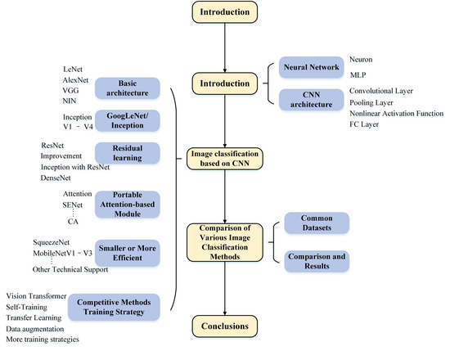

Figure 2. 1 Graphical Abstract of CNN Image Classification Algorithm. Source: Chen, L. et al (2021)

Machine learning for image recognition makes use of algorithms' capacity to extract latent knowledge from a dataset of both structured and disorganized samples (Supervised Learning). Deep learning is the most widely used machine learning technique, where a model has several hidden layers. For picture categorization, a variety of machine learning techniques can be applied, each with advantages and disadvantages. In this thesis, we’ll explore three commonly employed machine learning algorithms for image classification:

1. Convolutional Neural Networks (CNNs):

- CNNs are the most popular choice for image classification tasks.

- They are designed to automatically learn hierarchical features from images through convolutional layers.

- CNNs have been highly successful in various computer vision tasks due to their ability to capture spatial and hierarchical patterns.

2. Random Forest:

- Random Forest is an ensemble learning method that can be adapted to image classification.

- It can handle high-dimensional data and is robust to overfitting.

- Random Forest combines the predictions of multiple decision trees, making it a versatile choice for classification tasks.

3. K-Nearest Neighbors (KNN):

- KNN is a simple yet effective algorithm for image classification.

- It classifies an image based on the majority class among its k-nearest neighbours in the feature space.

- KNN is particularly useful when dealing with small to medium-sized image datasets.

## Research From Related Works

Different forms of algorithms can be applied in image classification problems and a good number of researchers have demonstrated this in different studies and works, usually when data related tasks are dissected, it is always a question of if data provided is enough, this is a common phenomenon with deep learning as the quantity of valid data largely affects the computation, Zheng, W. et al, 2021 designs a multi-scale meta-relational network, a classification method based on optimized initialization representation, for image with few samples. The group designs a multi-scale meta-relational network (MSNN). Initially, the multi-scale meta-relational network incorporates the concept of meta-SGD and uses the inner learning rate as both the model parameter and the learning vector in order to learn jointly. Second, the multi-scale meta-relational network uses the MAML method during the meta-training process to discover the model's ideal parameters. In contrast, the inner gradient iteration is removed and the test is conducted directly during the meta-validation and meta-testing processes. The experimental findings demonstrate that the metric learning and optimized initial representation combined strategy outperforms the metric or optimized initial representation method alone. The taught measurement method's higher generalization ability is made possible by the multi-scale meta-relational network. This not only increases training time and classification accuracy on the benchmark set, but also prevents the requirement for fine-tuning of MAML. By training the multi-scale relational network on a variety of task Spaces, the multi-scale meta-relational network presented in their study is able to learn particular categorization tasks. Next, the MAML algorithm is applied to determine a set of highly adjustable parameters that may effectively leverage the experiential information acquired from earlier challenges and enable learning.

Big medical data mostly consists of genetic information, medical picture data, electronic health record data, and so forth. The great majority of medical data at this point is comprised of medical imaging data. How can clinical practice make use of massive medical data? Researchers in the fields of medicine and computers are quite concerned about this, and deep learning and intelligent imaging offer a good solution. (Cai, L. et al., 2020). Cai et al introduce in their paper, the application of intelligent imaging and deep learning in the medical space for early diagnosis of disease, combining latest researches of big data analysis of images, specifically classification and segmentation of medical images to conduct their research. They introduce the more classic and current mainstream network models for their purpose with focus on the algorithms from deep learning, the group runs through various networks including CNN., AlexNet, VGG16, GoogLeNet and a couple of segmentation networks such as SegNet, U-Net, etc. They also outline a couple of deep learning software development frameworks like Caffe, TensorFlow, PyTorch. Deep learning has advanced to the point that computer vision employs it extensively to solve a variety of image problems. Numerous scholars are interested in medical images because they are unique visual representations. Deep learning techniques have been used in recent years for a variety of medical image processing and recognition applications, such as fundus, endoscopic, CT/MRI, ultrasound, pathological, and other picture types. (Cai, L. et al., 2020).

Applications for satellite images are numerous and include environmental monitoring, law enforcement, and disaster response. The human identification of facilities and objects in the images is necessary for these applications. Automation is necessary since there are large geographic areas to cover and a limited number of analysts available to conduct the searches. (M. Pritt & G. Chern, 2017). In their work, Pritt & Chern establish a deep learning framework for categorizing facilities and items from the IARPA Functional Map of the World (fMvoW) dataset into 63 distinct groups. The system is made up of additional neural networks and a group of convolutional neural networks that combine image attributes and satellite metadata. It operates on a Linux server with the Keras and TensorFlow deep learning libraries and is implemented in Python with NVIDIA Titan X graphics card. Their system at its total completion has a total accuracy of 83% with an F1 score of 0.797 and it classifies 15 of the 65 classes with accuracies of 95%.

Medical imaging has advanced tremendously in the modern era of medicine and is now capable of obtaining many biological images from patients. Following this, these photos can be employed and educated in an intelligent system to help medical specialists identify the various disorders that can be diagnosed by analysing these images. In this context, classification is crucial since it improves the way these images are categorized into disease groups and streamlines the subsequent process of a computer-aided diagnosis system. In machine learning, the notion of categorization addresses the challenge of determining which category a newly formed population falls into. When it is known which categories a person belongs to, the classification is carried out using a training set of data that includes observations (Tchapga, C.T et al, 2021). In this 2021 paper, Tchapga and group analysed biomedical image classification and conducted a task using machine learning algorithms, the group conducted a survey of ML algorithms for image classification and went through a couple of algorithms including: Decision trees, Neural Networks, Naïve bayes, KNN, SVM and Rule-learning. The main objective of medical image classification is to identify which parts of the human body are infected by the disease and not only to reach high accuracy. (Tchapga, C.T et al, 2021). The process of their model creation utilising the different algorithms for accuracy purpose involved the following steps: The training phase, Labelled Biomedical Image, Feature extraction, Algorithm Implementation, Testing Phase, Unlabelled Biomedical image, Classifier and Prediction.

Wu, M. & Chen, L (2015) conducted an image recognition project using deep learning, applying deep learning to handwritten character recognition and exploring the two mainstream algorithms of Deep Learning: The Convolutional Neural Network (CNN) and the Deep Belief Network (DBN). The duo conducts a performance evaluation for CBN and DBN on the MNST database and the real0world handwritten character database. The classification accuracy rate of CNN and DBN on the MNIST database is 99.28% and 98.12% respectively, and on the real-world handwritten character database is 92.91% and 91.66% respectively. (Wu, M. & Chen, L., 2015).

## Research Gap

Towards the research process for this thesis, a number of things were revealed across other studies and in my findings. The utilization of machine learning as an emerging technology is a glorious evolution of the sciences and image classification using ML is one of the glorious results of its application as it automates the process of extracting data from imagery and generally digital visual data, despite this, a few constraints exist as hurdles in the course of this research and these could be; The underutilization factor that somehow was acknowledged by several authors to be one of the setbacks of the field, they collectively believe that more exploration of ML for image classification can be done and less than expected work has so far been done in that regard, there also exists the idea that textual and numerical data are better sources for data analysis, to draw inferences from and to make analysis on, this is substantiated by the existence of way more structured data in form of numerical figures and text than the analysis on unstructured data in form of images and photographs, the current space for image classification is believe to be underexplored and this is in a space where professionals and researchers consistently try, in the Nigerian space though, we can agree that the field is heavily underexplored as results from a survey shows this. The reluctance to utilize advanced and automated technology in so many industries across the country is alarming, this is heavily due to lack of funding for research, infrastructure, expertise, corruption, etc. Thus, all of the literatures reviewed hardly are situated in the African space and there is hardly African papers with in-depth knowledge on the science of image classification utilising machine learning. The complexity of the entire process which involves an arsenal of reformed and modern statistics, mathematics, computing, Artificial Intelligence, analytics and ML prowess over all is not easily attainable which is one of the reasons for this research, to highlight an area that could do wonders for industries across Nigeria, to shine light on the field of ML as an emerging technology and specifically intimate other researchers with the role of image classification in data analysis across industries.

## Summary of Related Works and Research

Table 2.1 provides a tabular summary of some of the key related works and literatures explored in the course of this thesis, spotting a comparative analysis of the algorithms, techniques, findings, implementations of the focus subject.

|  |  |  |  |  |  |  |
| --- | --- | --- | --- | --- | --- | --- |
|  | Machine Learning Models | Convolutional Neural network (CNN) | Field of Science Task Implementation | Non-Science Field Implementation | Existence of Practical Working Model for Image Classification | Problem of Under exploration |
|  |  |  |  |  |  |  |
| Meiyin Wu & Li Chen (2016) | YES | YES | NO | YES | YES: Image Recognition of Handwritten Characters | YES |
| Tchapga C.T et al (2021) | YES | YES | YES | NO | NO: Proposed workflow with Spark Algorithm | NO |
| Pritt Mark & Chern Gary (2017) | YES | YES | YES | NO | YES: Deep Learning System for classifying objects | NO |
| Cai, L., Gao, J. & Zhao, D. (2020) | YES | YES | YES | NO | NO: A review of deep learning algorithms application in classification and segmentation of medical images | NO |
| Qian Yufeng (2021) | YES | YES | YES | NO | NO: Exploration of ML algorithms based on feature extraction | YES |
| Chen, L. et al, (2021). | YES | YES | YES | NO | NO: Review of Image Classification Algorithms (CNN) | NO |
| Boesch, Gaudenz (2023). | YES | YES | YES | YES | YES: Retail Customer Segmentation | Face recognition in security | YES |
| Habib, A. et al (2023). | YES | YES | YES | NO | YES: Evaluation of generalisability of AI. Algorithms to detect middle ear disease | NO |
| Taye Mustafa, M. (2023) | YES | YES | YES | NO | NO | YES |
| Ang, L.K et al (2022) | YES | YES | YES | YES | YES | NO |

## **CHAPTER THREE: RESEARCH DESIGN AND METHODOLOGY**

Recurrently established, is the need to create more existing material for image classification using Machine Learning as an emerging technology, especially for the still developing African science community. Data analysis creates a doorway of insights to possibilities surrounding pivotal decision-making processes across numerous industries and a large amount of data resides in imagery and visual content; analysis, interpretation and utilisation of this data would most definitely be instrumental and produce profound results, this is already the status quo where image classification has been applied in fields like medicine, security, traffic control, agriculture, etc.

This chapter of this thesis analyses the strategic routes implemented towards the success of the plan of the laid-out research goals for this study. In this chapter we establish a walkthrough of the research design format and the research methods implemented for the realization of the study.

## Research Design

Explaining the type of research conducted in this thesis is the entire essence of the research design phase. The study lifecycle is an iterative process beginning from the definition of the problem, to the data collection and research from existing literature to the cross examination of data collected from materials and sources, sifting through necessary and unnecessary data to the data analysis phase utilising the ML algorithms, obtaining results and finally interpretation of the results and applying them. This workflow allows for the processes to be revised or revisited in order to get the research right. The research design technique for this thesis is multi-faceted. The entire study is geared towards contributing to the pool of knowledge in the image classification space using ML as an emerging technology, to achieve this goal; a popular image classification method is employed image recognition”. This paper is guided by a systematic workflow in its design method, this workflow is the framework by which the study is conducted. The research design for an image classification project in machine learning typically follows a standard pattern, which includes several phases and methodologies. Here's an overview:

1. Problem Definition and Domain Understanding:

- Start by defining the problem you want to solve with image classification.

- Understand the domain or industry in which your problem resides.

- Identify the specific task, such as binary classification, multi-class classification, or object detection.

2. Data Collection:

- Gather a dataset of labelled images relevant to your problem.

- Ensure your dataset is diverse, representative, and of sufficient size.

- Split your dataset into training, validation, and test sets.

3. Data Pre-processing:

- Clean the data by removing duplicates and outliers.

- Resize images to a consistent size.

- Normalize pixel values.

- Augment the data with techniques like rotation, cropping, and flipping to increase diversity.

4. Model Selection:

- Choose an appropriate deep learning architecture (e.g., Convolutional Neural Network, or CNN) based on the complexity of your problem.

- Consider pre-trained models for transfer learning if your dataset is small.

5. Model Training:

- Train your model on the training dataset using appropriate loss functions and optimization algorithms.

- Monitor training progress and use techniques like early stopping to prevent overfitting.

- Tune hyperparameters, such as learning rate and batch size.

6. Model Evaluation:

- Evaluate your model's performance on the validation set using metrics like accuracy, precision, recall, F1-score, and confusion matrix.

- Fine-tune the model based on validation results.

7. Testing and Generalization:

- Assess your model's performance on the test set to gauge its ability to generalize to new, unseen data.

- Calculate and report evaluation metrics on the test set.

8. Interpretability and Visualization:

- Make the model's predictions interpretable, especially in critical applications.

9. Model Deployment:

- Deploy the trained model in a production environment.

- Integrate it with the application or system where it will be used.

The specific research design can vary based on the complexity of the image classification problem, the available resources, and the goals of the project. Additionally, researchers may experiment with different architectures, techniques, and datasets to improve model performance. The iterative nature of deep learning research often involves revisiting and refining various stages of the design process to achieve better results. Research method employed is a quantitative approach with an experimental research design as the de facto approach. To highlight, inform, educate and practically showcase the use of Machine Learning in image classification; more than one algorithm is applied to find the best fit to responding. In this study, we pick a category to show a working model with and then using the set of aforementioned ML algorithms for image classification problems, each algorithm is applied and results compared to find the best fitting also known as the algorithm with the highest level of accuracy, this becomes the best algorithm for a working model. This entire approach is heavily experimental as it involves a good margin of testing and analysis through the different ML algorithms. Data for this experimental approach is obtained from different sources and for different purposes, all defined by the research questions.

## Empirical Study

Factual data are referred to as empirical evidence. The majority of factual data are expressed as verifiable and certified numerical figures. Experiments and observations are carried out in a controlled setting to gather raw data. Primary sources, such as surveys, observations, documentation, and experiments, can be used to gather empirical data. Newspapers, journals, and other published materials are considered secondary sources. There are three types of empirical data: qualitative, quantitative, and mixed. (Wallstreetmojo, 2023).

We would be relying on secondary data source for this study, bringing key features from key materials explored; we set to explore the algorithms to be applied in the conduct of the study’s experimental research design process; utilising qualitative data for this part of the thesis. To ensure that primary data also exists, a questionnaire is prepared and served to the general public with a directed target in selection of response sample at individuals with some experience or a lot of experience in the field of the sciences. Looking at the different algorithms to be experimented in the course of our development process, the empirical study of this thesis will feature informative insight on these algorithms:

1. Convolutional Neural Network (CNN)

A Convolutional Neural Network (CNN) for image classification is a deep learning model specifically designed to process and analyse visual data, such as images, and classify them into predefined categories or classes. In a variety of computer vision applications, such as segmentation, object identification, and image classification, CNNs have demonstrated remarkable effectiveness. Because CNNs can automatically learn the spatial hierarchies of characteristics, including edges, textures, and forms, which are crucial for identifying objects in photos, they are particularly good at classifying images. CNNs process the input data through a network of interconnected layers. Convolutional layers are often the first hidden layer in a CNN. They work by applying a series of filters to the input data in order to identify particular patterns. By swiping over the input data and multiplying each filter entry element-by-element, a feature map is produced for each filter. The model is then given non-linearities to learn more intricate patterns in the data by combining these feature maps and passing them via non-linear activation functions like the ReLU function. Additional convolutional layers, pooling layers, and fully-connected layers are examples of subsequent layers in a CNN. Feature maps are smaller when pooling layers are used. This improves the model's computational efficiency by lowering the total number of parameters. In most CNNs, fully-connected layers may be found following the convolutional and pooling layers. The model may learn potential non-linear combinations of the features learnt by the convolutional layers thanks to fully-connected layers, which link all of the neurons in one layer to all of the neurons in the layer above.

The final layer of a CNN is typically a softmax layer, which produces a probability distribution across the possible class labels for the input data. The class that has the highest probability is chosen as the prediction of the model. (Datagen, 2023).

1. Random Forest (RF)

The supervised classification algorithm family includes the Random Forest (RF) method (Breimann, 2001). The idea of decision tree learning that was introduced in the last session is expanded upon by RFs. The RF is based on numerous self-learning decision trees, which together form a "Forest." The rationale behind employing several decision trees, or an ensemble, is that numerous base learners can reach a single, solid conclusion as opposed to a single DT. The RF makes use of self-learning decision trees, in contrast to the manual (expert-based) creation of decision rules that we specified last week. Each node automatically defines rules as part of this "self-learning" process using a training dataset whose feature inputs and labels are known. The fundamental idea behind RF, which is made up of classification trees, is to combine several weak classifiers into a single powerful classifier. The training set is represented by the root node of the classification tree, each internal node by a weak classifier that separates the samples based on a particular attribute, and each leaf node by a labelled training or test set that divides the input data into multiple subsets.

The final decision result of RF is the optimal result chosen by voting on all classification trees. The Gini index is used to decide the optimal binary cut point for that feature. Random Forest is a popular ensemble learning algorithm typically used for structured data, tabular data, and non-image-based machine learning tasks. While it is not commonly used for image classification tasks due to the nature of image data, you can use Random Forest in combination with handcrafted image features or feature vectors extracted from pre-trained deep learning models for certain types of image classification problems. (Xi, E., 2022). while Random Forest is not the first choice for image classification problems, it can be used in scenarios where feature engineering and computational efficiency are key considerations. For most image classification tasks, especially those with large and complex datasets, deep learning models like Convolutional Neural Networks (CNNs) are preferred due to their ability to automatically learn relevant features from raw image data.

1. K- Nearest Neighbours (KNN)

Using k-Nearest Neighbors (KNN) for image classification is a viable approach, especially for small to medium-sized image datasets. KNN is a simple and interpretable classification algorithm that can be used effectively when combined with appropriate image feature representations and distance metrics. The workflow process using KNN is standardly something like this:

1. Feature Extraction:

Instead of using raw pixel values, you need to extract relevant features from the images. Feature extraction is crucial for KNN, as it relies on calculating distances between data points.

Common feature extraction methods for image data include Histogram of Oriented Gradients (HOG), Colour Histograms, Local Binary Patterns (LBP), or deep features from pre-trained Convolutional Neural Networks (CNNs).

1. Data Preparation:

For each image in your dataset, extract the chosen features, resulting in a feature vector for each image.

Combine these feature vectors with the corresponding class labels.

Split your dataset into training and testing sets.

1. Training:

KNN is a lazy learner, meaning it doesn't learn a model during training but memorizes the entire training dataset.

During training, KNN stores the feature vectors and class labels of the training data.

1. Classification (Inference):

To classify a new image, KNN calculates the distance between its feature vector and the feature vectors of all training examples.

The k nearest neighbours to the new image are identified based on the smallest distances.

Class labels from these k neighbours are collected, and the class with the majority vote among these neighbours is assigned as the predicted class for the new image.

1. Choosing 'k':

The choice of the number of neighbours 'k' is a crucial hyperparameter in KNN. You can use techniques like cross-validation to find the optimal 'k' for your dataset.

1. Distance Metric:

Select an appropriate distance metric, such as Euclidean distance or Manhattan distance, based on the nature of your feature vectors and the problem domain.

1. Model Evaluation:

Evaluate the KNN model on a separate testing dataset.

Use standard classification metrics like accuracy, precision, recall, and F1-score to assess the model's performance.

1. Tuning Hyperparameters:

Fine-tune hyperparameters like the choice of distance metric and the number of neighbours 'k' to optimize performance.

1. Interpretability:

KNN is interpretable, and it can provide insights into why a particular classification decision was made by examining the nearest neighbours.

## **Mixed Methods Research**

A Mixed Method Research is as the name implies, it is a combination of research methods, a research approach whereby researchers collect and analyse both quantitative and qualitative data within the same study. In the cause of this thesis, this experimental research designed study utilises quantitative and qualitative approaches as it’s a thoroughly informative documentation that utilises visual data and eventually also employs numerical data to run statistical computations of the algorithms experimented.

* + - 1. **Quantitative Research Approach**

The focus of quantitative research methods is on objective measurement and statistical, mathematical, or numerical analysis of data obtained via surveys, questionnaires, polls, or by computationally manipulating statistical data that has already been acquired. (Babbie Earl, 2010). In this paper, this research method was adopted to quantify, evaluate and interpret pre-existing numerical obtained from the Kaggle data source which makes up for the primary data of this research; this method makes presentation of numerical data simplified and readable by researchers.

## **Qualitative Research Approach**

Qualitative research methods focus on and involves collecting and analysing non-numerical data such as text, video, audio in order to understand concepts, opinions or experiences with the aim to gather in-depth insight into a problem, to generate new ideas for research or to solidify evidence of a research. While quantitative research method involves collecting and analysing numerical data for statistical analysis, qualitative research approach is quite the opposite. (Bhandari, 2020). This research method was adopted in this work to solidify the knowledge base for this research and strengthen the onus of this research from the experiences and responses of participants in the data gathering process which makes up for the secondary data of this research.

## Population of the Study

A population in research is a collection of individuals with the same characteristics and are of particular interest to the researcher based on the research questions and expectations. In the case of this study, the population for this research is streamlined to the entire set of images or image data relevant to this research objectives, the research objective is majorly to highlight the process flow of using ML for image classification which is why different algorithms will be utilised as per the experimental research design. The tasks defined for this purpose is an image recognition classification tasks, the expected model is a recognition system that can identify humans apart from animals, this means population for this study is a set of images comprising of humans and animal visuals for the purpose of training our model. To solidify the need for exposure on this rapidly spreading emerging technology, ML and its application in image analysis, a subset of individuals take part as members of the population asides the image data for the classification task; this is to establish a view from the general public on image analysis as a necessary science.

Thus, the population for this study is the dataset of images and visuals of humans and animals, as well as the general populace of persons (men and women) in science.

# **Sample and Sampling Procedure**

A sample is a subset of the entire population usually sharing some features remarkably similar to represent and characterise the entire population. The portion of a population used to typically carry out and confirm research is called a sample. The sampling procedure is simply the technique of selecting the sample used to carry out the research and there are different types of sampling procedures applied to different research types. For this study, a purposive sampling procedure is applied. The main objective of purposive sampling is to arrive as at a sample that can adequately answer the research objectives. The selection of a purposive sample is often accomplished by applying expert knowledge of the target population to select in a non-random manner a sample that represent a cross-section of the population. The experiment sample for the proposed image classification task is an image recognition system that tells apart the difference between a human and an animal, thus the expected model is one that on input, can detect if the image visible is human or animal. Hence, sample data is a subset of images of human samples and animal samples. The sampling procedure is purposive and not based on probability as the features we’ll be training the model to identify may not be in all animals thus room for some type of error may exist but the goal is for the model to capture the fundamentals to meet the requirements of this research.

# **Method of Data Collection**

Gathering data from various sources—both online and offline—by scraping, capturing, and loading it is known as data gathering. The most challenging aspect of a machine learning project can be creating or gathering large amounts of data, especially when working at scale. (Mirza, S., 2022). Machine learning models must be able to process vast volumes of structured training data in order to create intelligent applications with comprehension capabilities. The first step in resolving any machine learning issue is to collect enough training data. Since predictive models can only be as good as the data they are built on, effective data gathering techniques are essential to creating models that function well. Thus, for this research, the data collection method employed an examination of the data type necessary for the research, this is clearly image data, some text data for validation of research necessity is also obtained via a questionnaire. The main purpose of the data collection is to gather information in a measured and systematic way to ensure accuracy and facilitate data analysis. Since all collected data are intended to provide content for analysis of the data, the information gathered must be of the highest quality to have any value. (Mirza, S., 2022). Data collection is often an iterative process, and the quality and size of your dataset significantly impact the performance of your image classification model. Careful planning, ethical considerations, and rigorous quality control are essential when collecting image data for ML research. The data collection methods applied in this study:

1. Public Datasets: obtaining data from large public dataset libraries, many publicly available large image datasets are available and this is the method this thesis heavily relies on.
2. Data Augmentation: This involves a method where researchers can augment datasets by applying transformations to existing images, such as rotation, cropping, resizing, and changing brightness or contrast, for images that require some form of formatting, data can be augmented.

# **Data Analysis Method**

At the lowest level, computers operate with 1’s and 0’s. This is no different when working with images. Computers can represent an image as a matrix of 1’s and 0’s. When a computer displays an image, it displays a grid of pixels, each filled with one colour. Consider a very simple shape, such as the black triangle below. For image classification analysis, there are a couple of methods that can be applied for analysis purpose, in this study, we’ll be looking at Supervised and unsupervised ML analysis methods. McKee, 2020 beautifully simplified these two image analysis concepts as follows:

**Image Analysis with Supervised ML Models**

With supervised ML, you essentially give the computer a large number of images and label them ahead of time. It’s a little like teaching a baby what animals look like by pointing to them and saying, “This is an elephant.” It’s up to the baby to figure out a pattern for the things we call elephants and the things we call fish.

In supervised ML, the computer is doing similar work as that baby.

**Image Analysis with Unsupervised ML Models**

Unsupervised machine learning models offer exciting possibilities for image analysis by enabling the sorting of images into bins or categories without the need for labelled data.

Imagine having a vast collection of images and wanting to organize them into meaningful groups. Unsupervised ML models can analyse the visual features of the images and group them based on shared characteristics, like colour or shape. This provides valuable insights and simplifies image analysis tasks.

Some other data analysis technique we’ll be employing is:

**Feature Engineering:**

Examine the extracted or handcrafted features to ensure they capture relevant information from the images. Visualize extracted features to understand their separability across classes.

Data analysis is a crucial step in image classification to gain insights into the dataset, understand its characteristics, and make informed decisions throughout the research process.

Summarily, this chapter of this paper presents the approach and methods of research design, data gathering and collection process as well as data analysis methods applied to carry out this research. Research design maximises the effort of a research in the first place to answer the research questions of said research. Extensive detailing on the data analysis methods and approaches is contained in chapter four of this dissertation.

## **CHAPTER FOUR: ANALYSIS OF DATA AND DISCUSSION**

## 4.0. Introduction

This chapter provides an overview of the analysis process applied to data collected for demonstration of image classification using Machine Learning. Here, we will be in-depthly walking through the different ML techniques suggested to be employed in the process of this thesis, in order to represent a practical body of image classification using ML and provide answers to the questions of this research as well as lay emphasis on fulfilment of the research objectives.

## 

## **Overview of Data Collection**

To show practical implementation of image classification using Machine Learning, we will utilise data from two of the most popular data banks, Kaggle and TensorFlow. Utilizing data from the large public library, we will conduct analysis. Kaggle is an online platform and community, that provides datasets for data science and machine learning research and practice, and offers a wide range of resources for data scientists, machine learning engineers, and researchers. Kaggle hosts a vast repository of datasets, making it a valuable resource for data exploration, analysis, and research. Users can upload, share, and access datasets on a wide range of topics. Kaggle often partners with organizations to provide datasets related to real-world challenges, such as predicting disease outbreaks or climate changes. This practical aspect makes Kaggle a hub for impactful research, thus data obtained from Kaggle is very much solid and reliable for big Data related projects such as this one. TensorFlow is another reliable open-source software library for machine learning and artificial intelligence, it is free and can be used across a range of tasks, but has a particular focus on training and inference of deep neural networks, this is what we rely on for image classification performance with CNN as this is a deep learning procedure and goes beyond common ML algorithms. TensorFlow is a rich system for managing all aspects of a machine learning system and this certainly came in handy in the course of this study. Data collected from Kaggle was data utilised for Image Classification using the common ML algorithms, namely; Random Forest and K-Nearest Neighbours. Data obtained from TensorFlow is the data we emphasized in earlier chapters for a model that should distinguish between animal and human image, specifically the image of a horse as animal. Each individual data source proved to be a very useful and reliable library for the implementation of the research objectives and goal.

## **Research Instruments**

The research instruments refer to the tools used to collect, measure and analyse data related to the subject at hand, beyond just data collected, this also refers to the entire process of implementation and the instruments that make implementation possible. In carrying out this study, our two open-source libraries served as powerful databanks for the implementation of the study, making them major instruments of the research process. Beyond these libraries, the other instruments utilized include the tech stack exploited for actualization of the study; these are: Python, Google Collab, Anaconda, Jupyter Notebook, TensorFlow, Keras, Numpy, etc. These combined are the driving instruments for the implementation of the image classification task and experiment demonstrated in this thesis.

## **Reliability and Validity of Instruments**

Reliability of instruments for research is basically the extent that the instrument yields the same result over multiple trials and Validity on the other hand refers to the extent that the instrument measures what it was designed to measure. There are various ways to test for the reliability and validity of research instruments and in this study, we model our method according to the “Inter-rater reliability”. The Inter-rater reliability test involves using multiple researchers to assess a sample group and comparing their result, this is something we imitate as for our research objective of demonstrating image classification with Machine Learning, we set out to utilize different ML algorithms to run the same data sample and compare result. This allows for the best or most suitable algorithm to be selected at the end of the research process. In essence, the goal of establishing validity and reliability in research is to guarantee that the findings are accurate and the data are reliable and repeatable. To ensure the integrity and calibre of measuring devices, proof of validity and dependability is necessary. (Kimberlin & Winterstein, 2008).

## **Data Analysis**

Data collected from our most trusted and reliable open-source libraries “Kaggle and TensorFlow” is analysed and visualised using an array of statistical tools including graph plots. A large majority of our data collected, virtually all is in image format thus the normal statistical enumeration is not feasible with this sort of data and data analysis thus begins with a cleaning process to rid the data of corrupted image files or inappropriate file formats for the dataset, once data is cleaned and considered alright, analysis can commence. The analysis begins with splitting the dataset into test and train sets, for both data collected, we have large data sets for each group, the first image classification demonstration utilised data containing multiple image classes, this is referred to as a multi class supervised learning problem, as this data had large sets of various images, these classes were split into: airplane, automobile, cat, deer, dog, frog, horse, ship and truck, thus the expected final model should group whatever image received by the model into any of the classes the model perceives to be most likely the one the image input belongs to, this dataset contained a train dataset of 50,000 images and a test set of 10,000 images. After normalization of the datasets (train and testing sets) by dividing each set by 255, each set was converted to a 2D array, this is a delicate process to convert the image format to acceptable input for the models to run analysis, the models utilised here as stipulated in chapter 3 of this thesis were the Random Forest ML algorithm and KNN ML algorithm. After fitting the training set to the model, predictive computation is run with the test set and the model is up and running, we check to scrutinize the model, the accuracy and confusion matrix of the models, this process is done through both KNN and Random Forest ML algorithms.

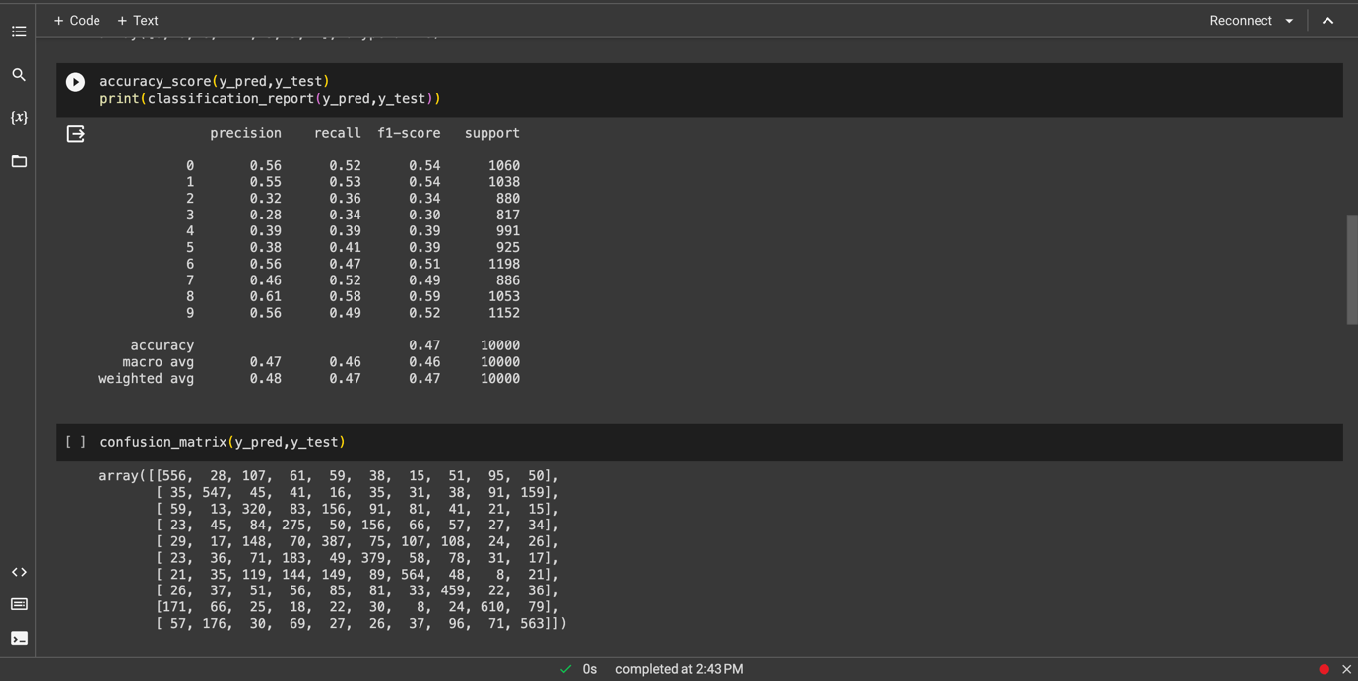

Figure 4. 1 Data analysis visualization for training data using Random Forest

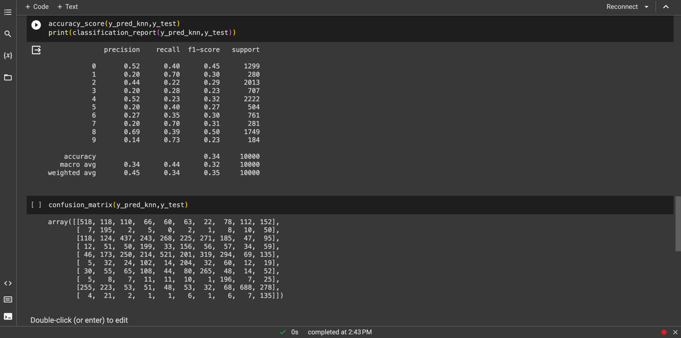

Figure 4. 2 Data analysis visualization for training data using KNN

The data analysis process for the CNN algorithm is slightly different and we demonstrate this using the horses or human dataset obtained from TensorFlow, the data is already clean and to ascertain this, we use an image generator to get images, this image generator creates the images for the analysis. It is a large data set generating 1027 images belonging to two classes of either horses or humans, unlike the dataset utilised for Random Forest and KNN ML algorithms, this classification problem has just two classes. The image generator generates images and we use the matplotlib module to visualise these image data, showing the human class and the horses’ class, after which building the model occurs, utilising powerful modules like keras, conv2D for conversion, MaxPool2D, etc. We examine the model accuracy and reliability by evaluating training and validation loss as well as, training accuracy and validation loss, visualising this process with a graph, we fit the model, load and can safely try put the recognition process using sample images that the model should determine to be either horse or human using CNN.

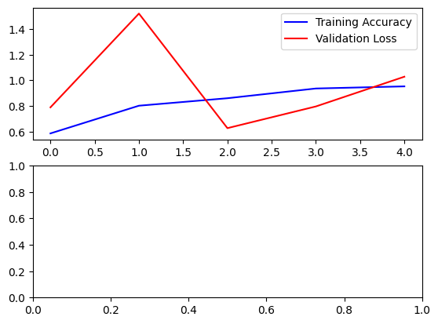

Figure 4. 3 Data analysis visualization for training data using CNN

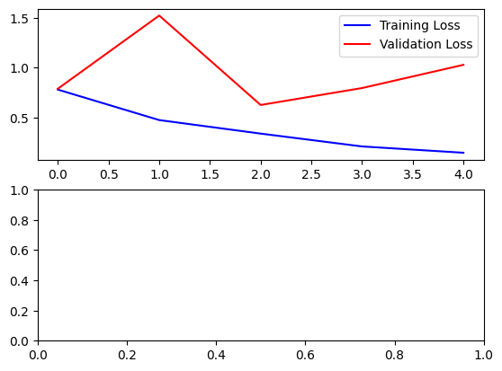

Figure 4. 4 Data analysis visualization for training data using CNN II

## **Research Question 1**

Figure 4.1 is a design outline of the variables that direct the flow of research question 1, this first question posed in this study aims at gaining insight and understanding to the concept this thesis seeks to unravel, “Image Classification”, Data analysis applied here was a descriptive and narrative approach to literatures reviewed alongside other sources.

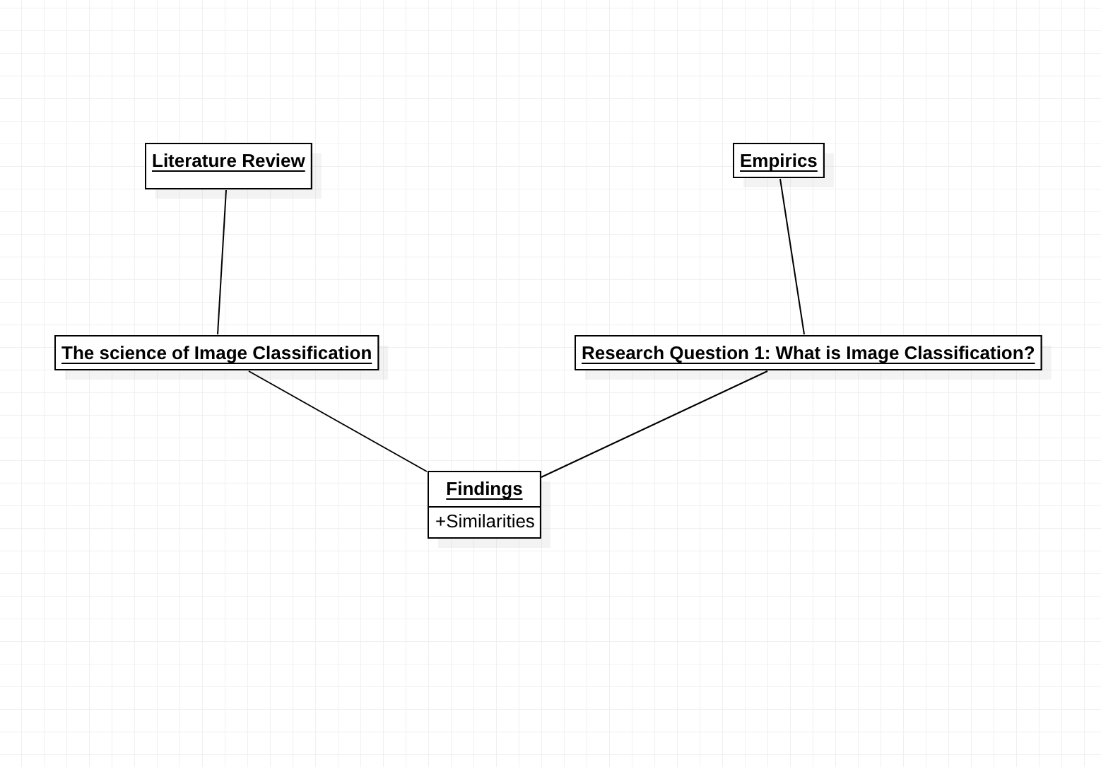

Figure 4. 5 Research Question 1

## **Research Question 2**

The second research question matches another objective of this thesis and puts this study path on a guide to discuss the importance of image data analysis across industries, figure 4. Shows the entity relationship diagram for this research question. Using descriptive analysis after examination of different sources and literatures, the importance of image data analysis in a fast-paced moving technology driven world cannot be overemphasized.

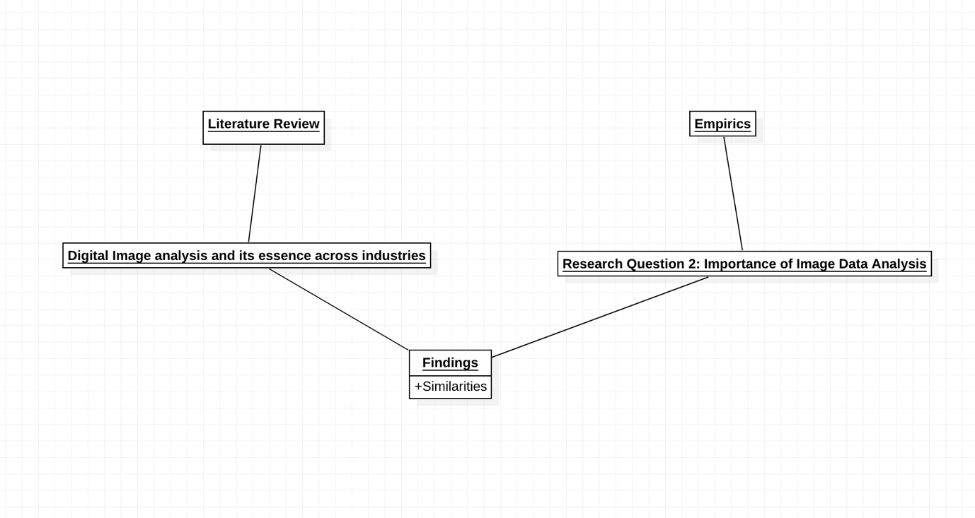

Figure 4. 6 Research Question 2

## **Research Question 3**

Research Question 3, drives this thesis to the heart of the study, as we present a descriptive analysis on Machine Learning as an emerging technology This leads us to a review of the algorithms and techniques applied to image classification problems using Machine Learning.

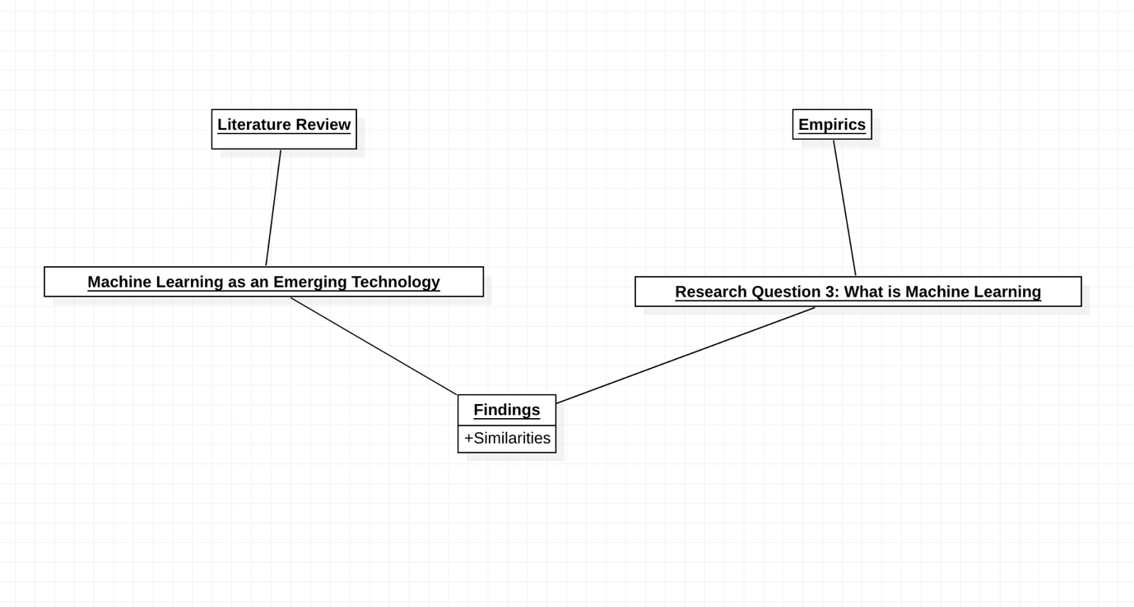

Figure 4. 7 Research Question 3

## **Research Question 4 & 5**

Leveraging on the finding of Research Question 3, Research Question 4 answers more questions on how to utilise Machine Learning as a tool for Image Classification, a proper demonstration of the algorithms reviewed in research question 3 is conducted. Here we perform a little descriptive analysis and widely focus on statistical analysis and implementation of the algorithms.

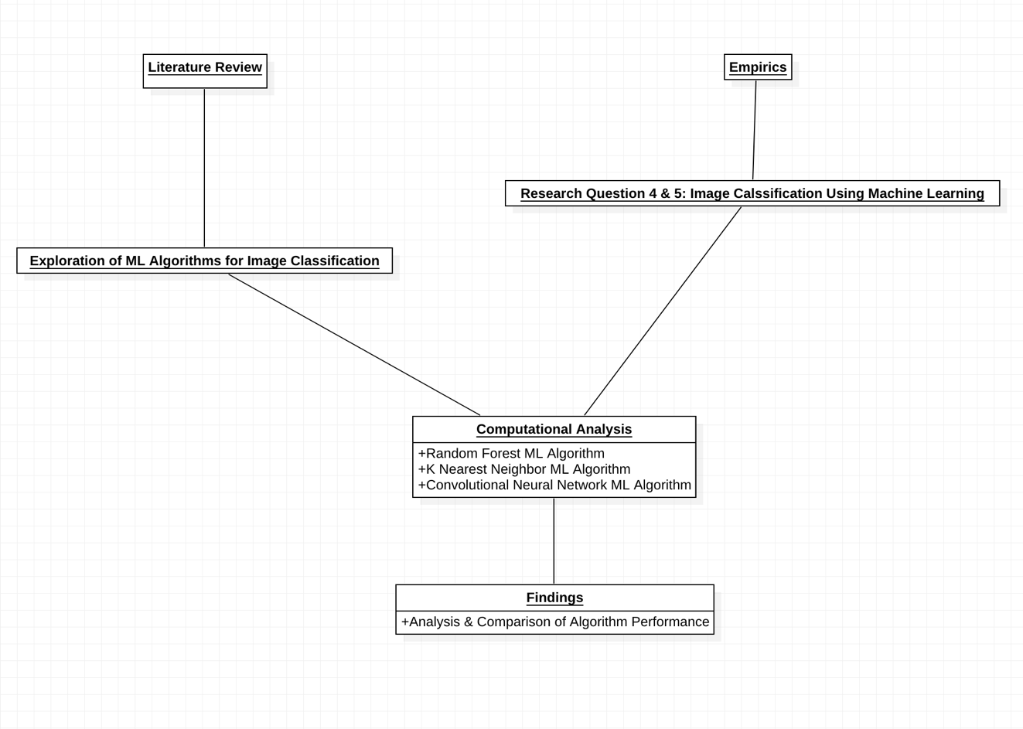

Figure 4. 8 Research Questions 4 & 5

## **Research Question 6**

This research question focuses on the aftermath of our study, analysing if Machine Learning is a good enough metric to improve image data analysis. Numerous studies have shown how ML algorithms have been the start point into futuristic image analysis but as technology evolves, other technologies are more paramount and effective as tools for image classification problems, this is where deep learning comes in, at one of its earliest forms of exploration, CNN as a deep learning algorithm is currently at the centre of progressive image classification problems and is described as the best technology to handle image data analytics problems.

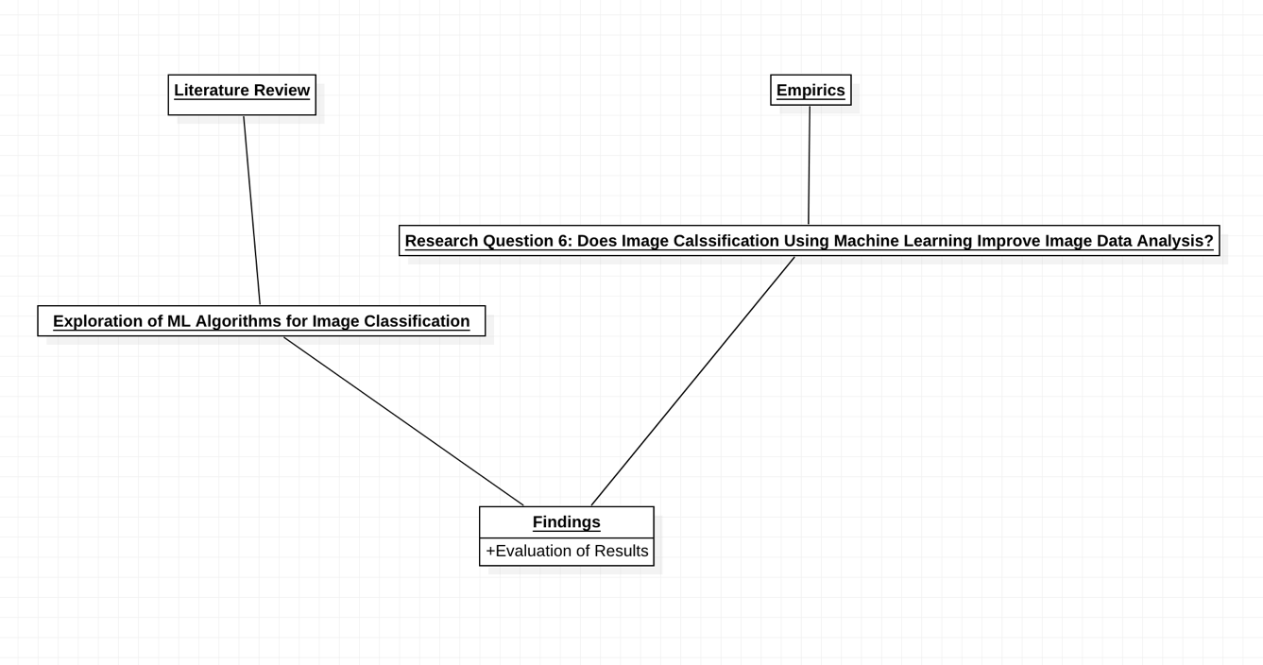

Figure 4. 9 Research Question 6

## **Discussion**

Conclusively, the pioneering goal of this study is to demonstrate image classification using Machine Learning, while informing and examining the concept of image data analysis as a whole. This requires an image recognition model implemented using machine learning as well as thorough review of existing literatures and works on the concept alongside research to fuel the entire endeavour.

To achieve the stipulated objectives and goals of the study, Google Collab and Jupyter notebook were the ideal IDEs used to build the models, all computational analysis utilised python-based ML and DL libraries and modules. The figures below show a sample of excerpts from the technology’s implementation.

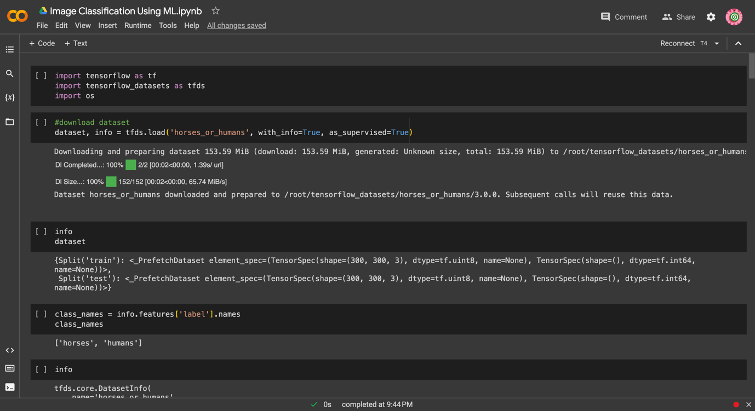

Figure 4. 10 Code excerpts of image classification implementation

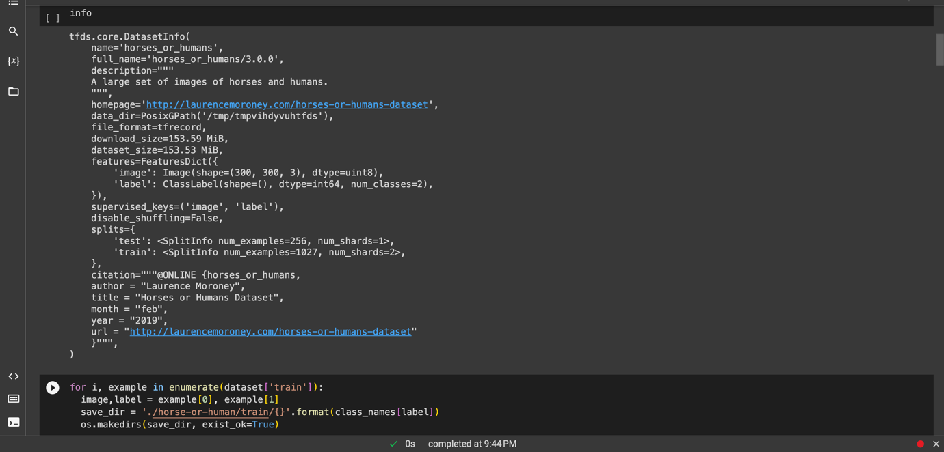

Figure 4. 11 Code excerpts of image classification implementation II

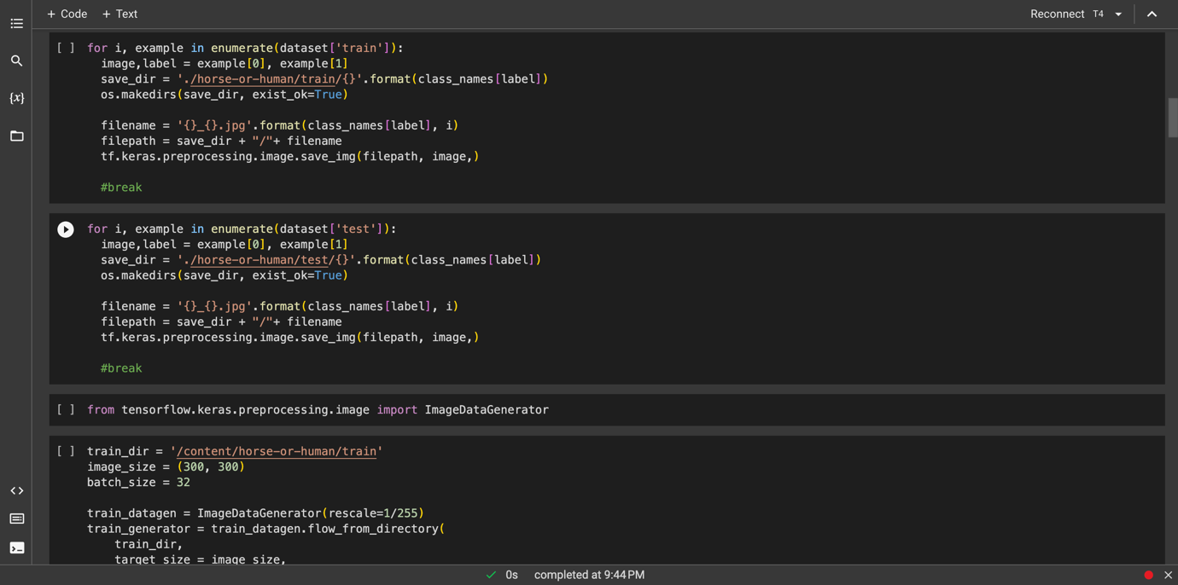

Figure 4. 12 Code excerpts of image classification implementation III

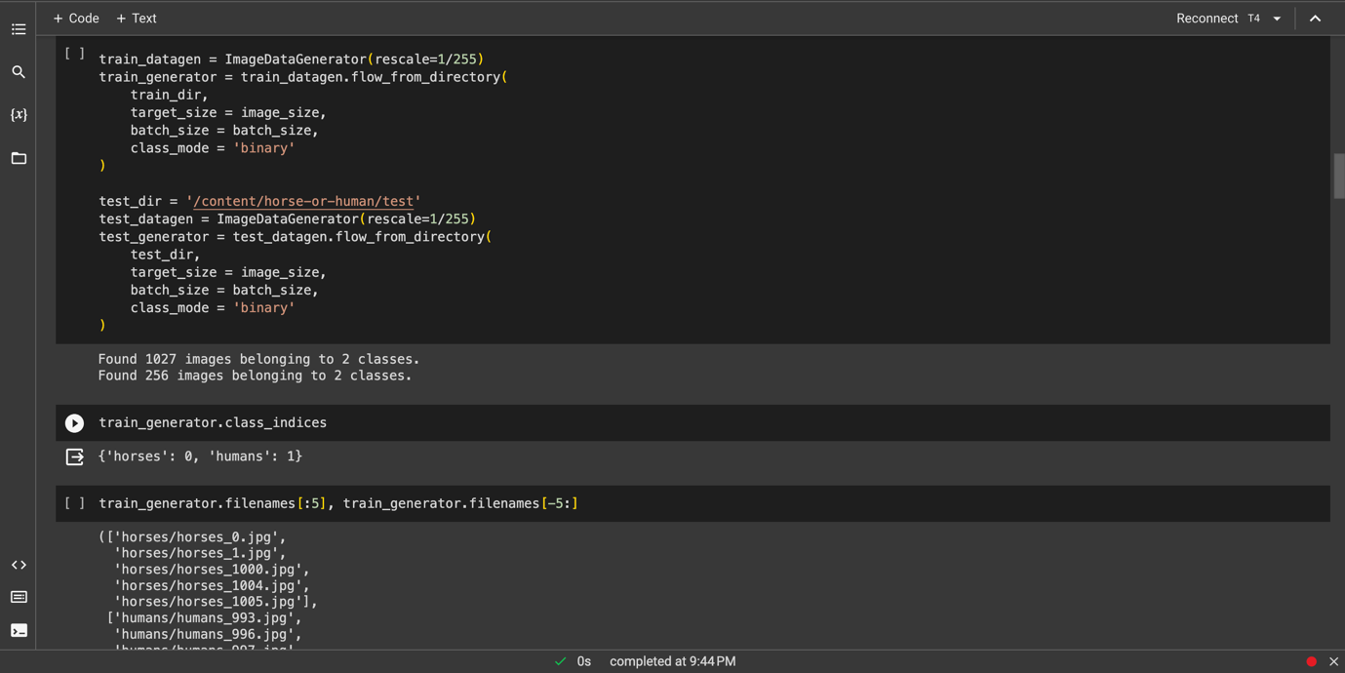

Figure 4. 13 Code excerpts of image classification implementation IV

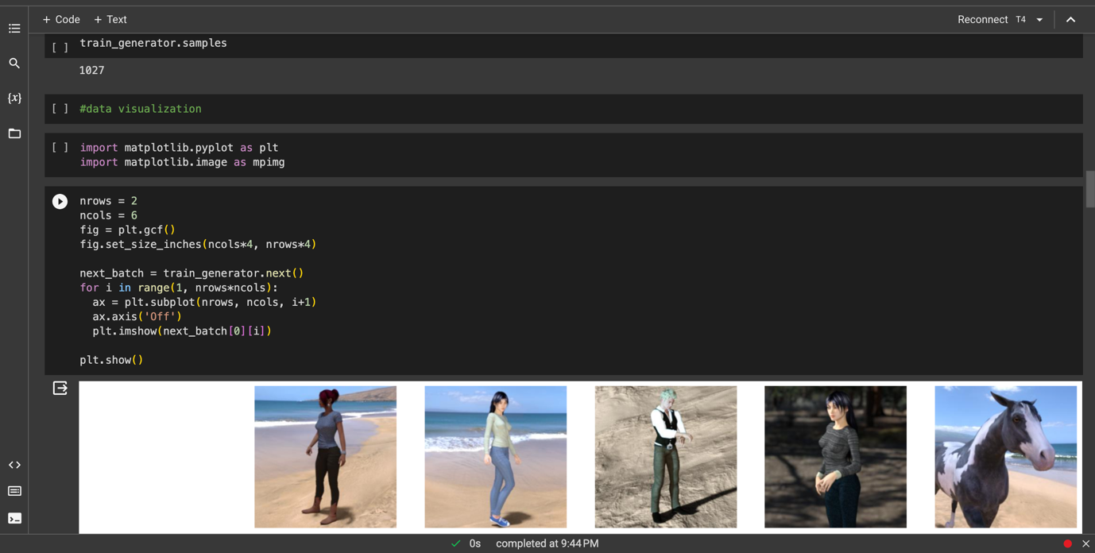

Figure 4. 14 Code excerpts of image classification implementation V

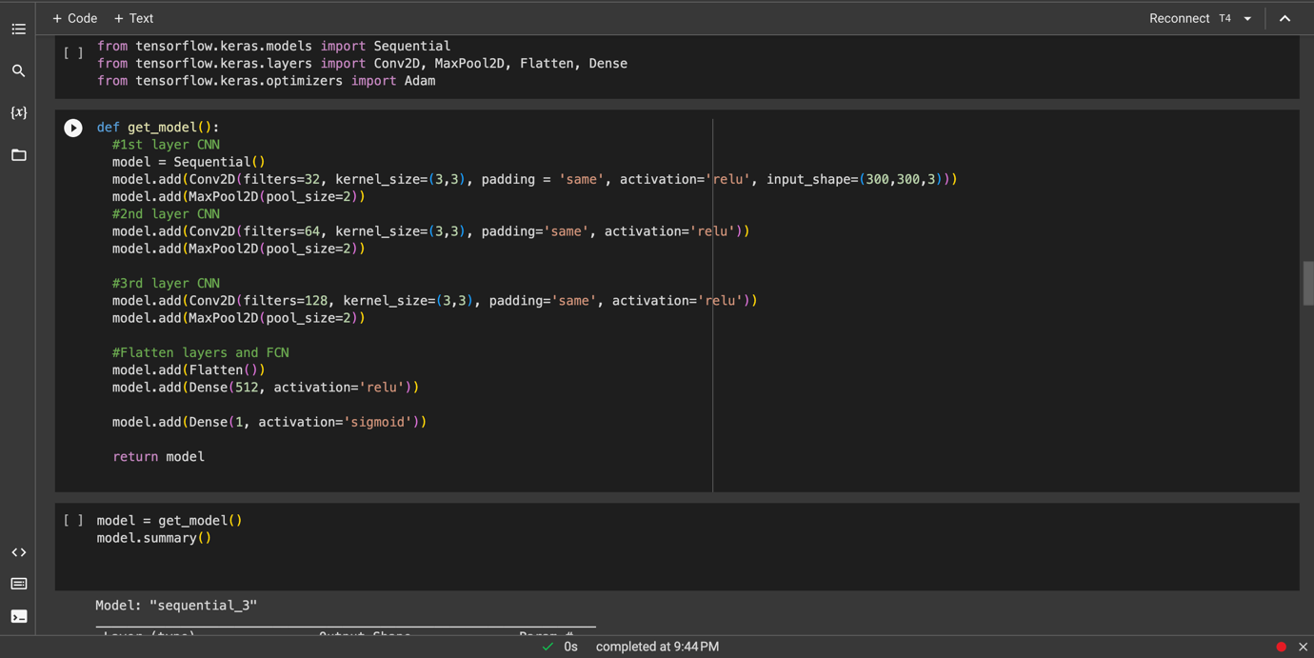

Figure 4. 15 Code excerpts of image classification implementation VI

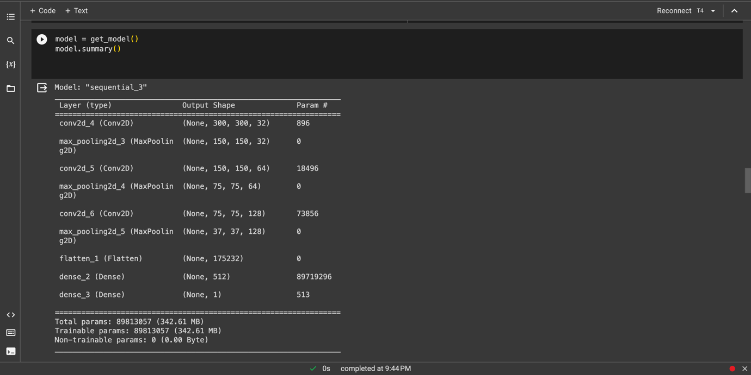

Figure 4. 16 Code excerpts of image classification implementation VII

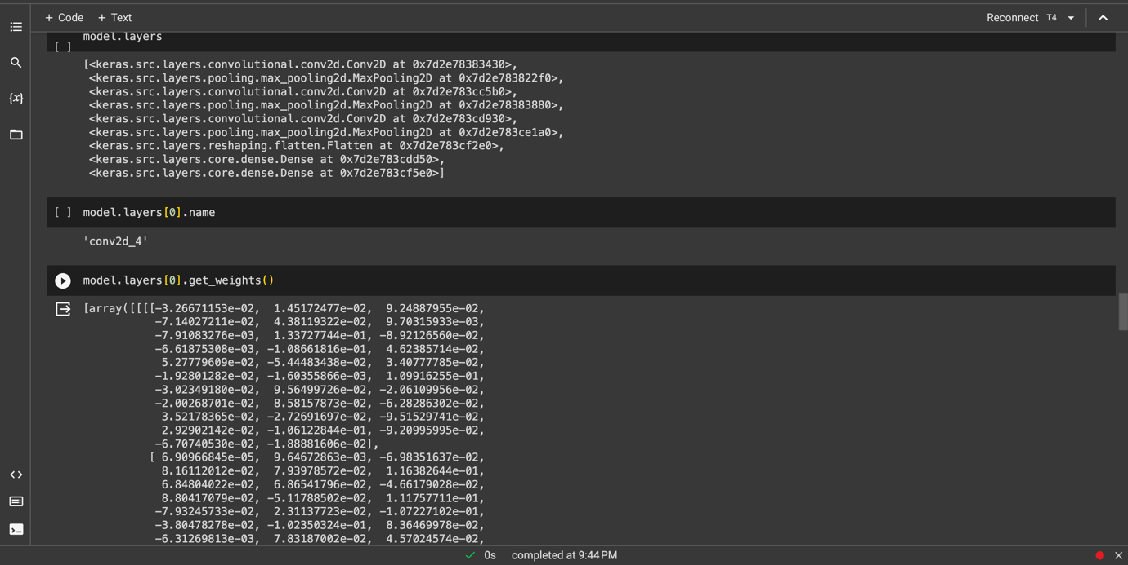

Figure 4. 17 Code excerpts of image classification implementation VIII

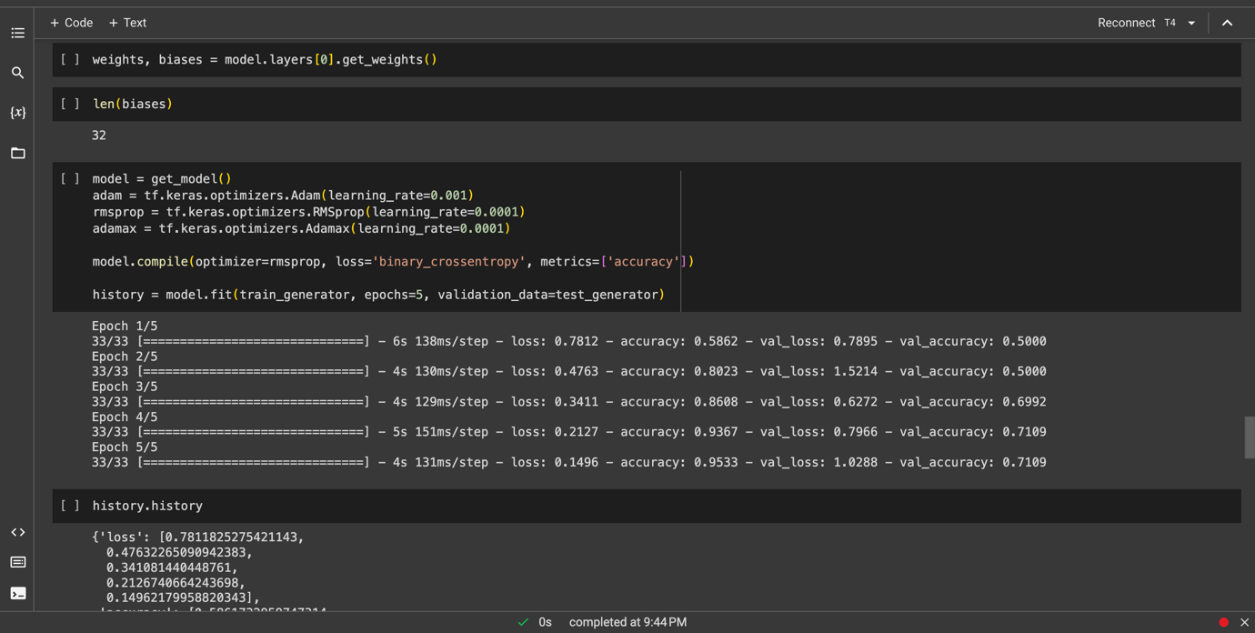

Figure 4. 18 Code excerpts of image classification implementation IX

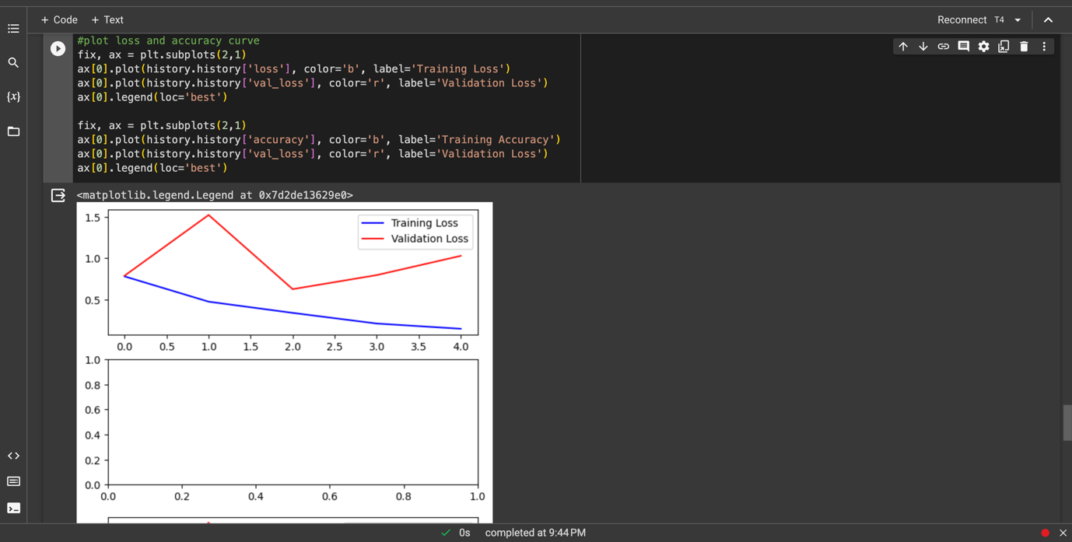

Figure 4. 19 Code excerpts of image classification implementation X

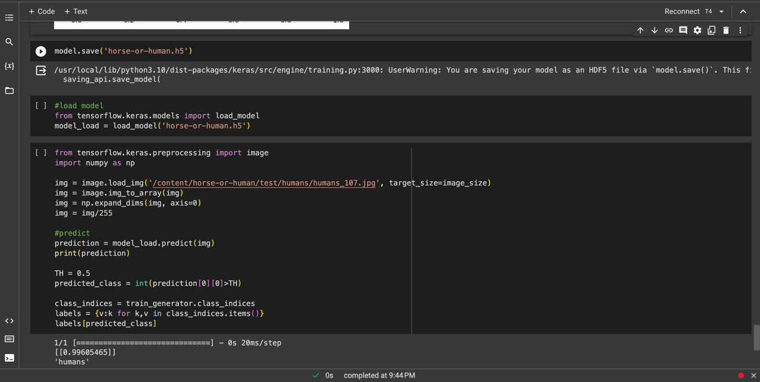

Figure 4. 20 Code excerpts of Image Classification implementation XI

## **Technologies Implemented**

To successfully carry out this research process and wholesomely answer the research questions, consequently meeting the research objectives, certain technologies were utilised:

The entirety of the analytical and computational part of the image classification tasks was built on Python programming language, using Kaggle and TensorFlow as libraries which held the data sources used in the image classification tasks and Google Collab as a major environment to run the analysis. The ML algorithms, techniques and libraries applied to demonstrate the entire essence of the paper also constituted as part of the technology utilised. Technologies used thus include:

1. Python programming language
2. Jupyter notebook of Anaconda ide
3. Google Collab ide
4. Kaggle
5. TensorFlow
6. Random Forest
7. K Nearest Neighbours
8. Convolutional Neural Network

## **CHAPTER FIVE: SUMMARY AND CONCLUSION**

## **Introduction**

Image classification is a fundamental task in computer vision with widespread applications, ranging from medical diagnosis and autonomous vehicles to content recommendation and security systems. This project aims to explore and implement machine learning techniques for image classification. This exploration proceeds with acquisition and pre-processing of a diverse dataset of images, ensuring data quality and integrity. Applying machine learning algorithms, employed and compared for their performance in classifying images into predefined categories, the entire venture is to emphasize the importance of image data analysis, to reinforce the need to understand all forms of data including images and to be able to build systems that can utilise image data analysis for enhancement in one’s field, this study presents practical demonstration of image classification using machine learning.

## **Summary**

In data analysis, image classification is a valuable tool for extracting insights from visual data, automating tasks that require visual recognition, and making data-driven decisions based on image content. It plays a pivotal role in industries ranging from healthcare and agriculture to retail and security, enhancing our ability to harness information from the visual world. Image data analysis as a technology has evolved through time and one of such ways of its evolution is the technology, Machine learning for image recognition makes use of algorithms' capacity to extract latent knowledge from a dataset of both structured and disorganized samples (Supervised Learning). Deep learning is the most widely used machine learning technique, where a model has several hidden layers. This study does not go in-depth into the exploration everything about image classification using machine learning but creates an exposé on what image data analysis is, its necessity, possible industry applications and at the end presents a demonstration of an image classification task using three different ML algorithms, each at different levels of sophistication and accuracy utilizing two different datasets to showcase these ML algorithms and their application.

Summarily, through the research conducted in this thesis, we analyse and understand image data analysis better and examine how machine learning can be used in image classification tasks in order to influence and improve decisions derived from data.

## **Findings of the Study**

At the end of the study, we arrive at a revelation packed research material put together through all forms of research review, experimentation, study and demonstration conducted in the course of the research process.

This revelation is simply a comprehensive computation that emphasizes the answers to our research questions; detailing what image classification is, the importance of image analysis, exploring machine learning and how it can be used for image classification. The final question of this study settles on the improvement of image data analysis with machine learning, it is a question of “does image classification using Machine Learning improve image data analysis”? When you compare traditional digital image analysis methods to new technologies of machine learning, this is a question that is certainly answered in the affirmative, as ML computations applied to data problems makes the processing faster, easier and less ambiguous.

Applying the three different ML algorithms- Random Forest, KNN and CNN. With more confidence, we sight CNN as the preferred algorithm to conduct image data analysis, we found this process utilising the TensorFlow data to be most seamless with less computational error and higher accuracy. Many studies reveal that CNN is currently the best algorithm to run image data analysis with as it is the most recent ML technology and is wat is called a Deep Learning model, this goes beyond the more common Machine Learning algorithms utilised less often for image classification tasks, for better results Convolutional Neural Network is preferred.

While we try to harness the superpowers of Machine Learning on image classification, in our research process, there are limitations we encounter which we discuss in 5.3.1.

## **5.3.1. Limitations of the study**

The entire research process was not without setbacks and in this part of the study, we highlight these setbacks, otherwise referred to as limitations of the study.

1. Research material on image data analysis is not quite as extensive as one would hope, the space of image analysis and classification with machine learning is mostly saturated with theoretical bodies of work and hardly practical demonstrations which makes it a stringent process to find relatable material. This does not suggest that required material does not exist, it just merely means that it takes a lot of input to get desired output where research material is concerned.
2. Machine Learning algorithms require large datasets to better perform, especially the deep learning algorithms, thus to utilise the algorithms, it is essential to find really large datasets or amass really large data. Of course, time limitation would not allow for a customised curation of data for this study purpose which is why the best alternative turned out to be open-source libraries, Kaggle and TensorFlow. Scouring these libraries for the right kind of data proved to be a setback as we had specific data outlined to carry out the image classification.

## **5.4. Constitution to Knowledge**

Building a documentation that would serve to inform about image classification using machine learning is one of the major relevance of this study and this is achieve with conclusion to the research process. We run ana analysis of image data and present the how and why in this thesis, this prepares the next researcher for the process and guides with a demonstration of our sample research. This work adds and solidifies the existing body of literature. On image classification using machine learning through its research process and implementation.

## **5.5. Recommendations**

Upon completion of the study, documenting the research process and all, there are a few recommendations for future work that would better optimise work done and increase efficiency value.

First, this research can be applied to simple image classification tasks for image recognition-based problems. It is very important to note the need to utilise really large datasets for this process.

Also, more examination and study time should be allocated to the field of machine learning, future researchers can make more expansive research and find ways to implement research in the status quo of our environs.

This thesis makes a good data bank for other data scientists and researchers as it provides information on machine learning and image classification, more practical demonstration using ML algorithms on image classification problems across different industries would be very good additions.

## References

Baier, D., Daniel, I., Frost, S & Robert, N. (2012). Advances in Data Analysis and Classification. *Image data analysis and classification in marketing.* DOI: DO1.10.1007/s11634-012-0116-0.

Burns, L.B., Rhoaads, D.D. & Misra, A. (2023). Journal of Clinical microbiology. *The use of ml for image analysis: artificial intelligence in clinical microbiology.* DOI: DOI: <https://doi.org/10.1128/jcm.02336-21>.

Belcher, B.T., & Kulkarmi (2023). Frontiers in Marine Science. *Demystifying image based ML: a practical guide to automated analysis of field imagery using modern ml tools.* Vol 10. DOI: <https://doi.org/10.3389/fmars.2023.1157370>.

Marr (2018) in Belcher, B.T., & Kulkarmi (2023). Frontiers in Marine Science. *Demystifying image based ML: a practical guide to automated analysis of field imagery using modern ml tools.* Vol 10. DOI: DOI: <https://doi.org/10.3389/fmars.2023.1157370>.

Norouzzadeh et al (2018) in Belcher, B.T., & Kulkarmi (2023). Frontiers in Marine Science. *Demystifying image based ML: a practical guide to automated analysis of field imagery using modern ml tools.* Vol 10. DOI: DOI: <https://doi.org/10.3389/fmars.2023.1157370>.

Godwin et al (2012) in Belcher, B.T., & Kulkarmi (2023). Frontiers in Marine Science. *Demystifying image based ML: a practical guide to automated analysis of field imagery using modern ml tools.* Vol 10. DOI: DOI: <https://doi.org/10.3389/fmars.2023.1157370>.

Katiia et al (2022) in Belcher, B.T., & Kulkarmi (2023). Frontiers in Marine Science. *Demystifying image based ML: a practical guide to automated analysis of field imagery using modern ml tools.* Vol 10. DOI: DOI: <https://doi.org/10.3389/fmars.2023.1157370>.

M. Pritt and G. Chern, (, 2017). Satellite Image Classification with Deep Learning. 2017 IEEE Applied Imagery Pattern Recognition Workshop (AIPR), Washington, DC, US. Pp. 1-7. DOI: 10.1109/AIPR.2017.8457969.

Christian Tchito Tchapga, Thomas Attia Mih, Aurelle Tchagna Kouanou, Theophile Fozin Fonzin, Platini Kuetche Fogang, Brice Anicet Mezatio, Daniel Tchiotsop. (2021). *Journal of Healthcare Engineering*. Biomedical image classification in a big data architecture using machine learning algorithms. Article ID 9998819, 11 pages, 2021. <https://doi.org/10.1155/2021/9998819>

Wu, M. & Chen, L. (2016). 2015 Chinese Automation Congress. *Image recognition based on deep learning*. **DOI:**[10.1109/CAC.2015.7382560](https://doi.org/10.1109/CAC.2015.7382560)

Cai, L., Gao, J. & Zhao, D. (2020). Annals of Translational Medicine. *A review of the application of deep learning in medical image classification and segmentation*. Vol 8(11). PMC7327346

Qian, Y. (2021). Mathematical Biosciences and Engineering. *Exploration of machine algorithms based on deep learning model and feature extraction.* Vol 18(6): 7602-7618. DOI: 10.3934/mbe.202136

Chen, l., Li, S., Bai, Q., Yang, J., Jiang, S. & Miao, Y. (2021). Deep Learning for Remote Sensing Image Classification. *Review of image classification algorithms based on convolutional neural networks.* VOL 13(22).

Habib, A., XU, Y., Bock, k., Mohanty, S., Sederlom, T., Weeks, W.B, Dodhia, R., Ferres, J.L, Perry, C., Sacks, R. & Singh, N. (2023). Scientific Reports. *Evaluating the generalizability of deep learning image classification algorithms to detect mid ear disease using otoscopy*. Vol 12(5368).

Boech, G. (2023). Viso Suite Viso AI Computer Vision. *A complete guide to image classification in 2023.* <https://viso.ai/computer-vision/image-classification/>

Taye, M.M. (2023). Data Science and Artificial Intelligence. *Understanding of machine learning with deep learning: architectures, workflow, application and future directions.* Vol 12(5), 91; DOI: <https://doi.org/10.3390/computers12050091>

Luo, L. (2021). Journal of Physics: Conference Series. *Research on image classification algorithm based on convolutional neural network.* Vol 2083(2). DOI: 10.1088/1742-6596/2083/3/032054

Ang, L.K., Seng, P.K.J., Ngharamike, E. & Ijemaru, G. K. (2022). International Journal of Geo-Information. *Emerging technologies for smart cities transportation: geo-information, data analytics and machine learning approaches.* Vol 11(2) 85; DOI: [**https://doi.org/10.3390/ijgi11020085**](https://doi.org/10.3390/ijgi11020085)

Philip, J. (2021). Organizational Management Journal.  *A perspective on embracing emerging technologies research for organizational behaviour.* Vol 19(3).

Xin, M. & Wang, Y. (2019). EURASIP Journal on Image and Video Processing. *Research on image classification model based on deep convolution neural network.* (40).

Lu, D. & Weng, Q. (2007). International Journal of Remote Sensing. *A survey of image classification techniques for improving classification performance.* Vol 28(5). DOI: <https://doi.org/10.1080/01431160600746456>

Kiadi, M. & Tan, Q. (2018). The International Conference on Advanced Machine Learning Technologies and Applications. *Machine learning: a convergence of emerging technologies in computing.* (Pp. 181-192). DOI: 10.1007/978-3-319-74690-6_18

Selles. M.A, Caballero, S.S., Caturla, G.J., Gonzalez, O. & Peydro, M.A. (2021). The First International Electronic Conference on Metallurgy and Metals. *Recent advances in digital image analysis applied to metal forming.* Vol3 (1). DOI: <https://doi.org/10.3390.IEC2M-09249>

Jelinski, T. (2002). Institute of Animal Reproduction and Food Research. *Digital image analysis- essence and application in cereal science.* DOI: 10.1007/978-1-4615-0085-8

Xi, E. (2022). *Image classification and recognition based on deep learning and random forest algorithm.*

Taha, B. (2021). Data Science Blogathon. Analytics Vidhya. *Build an image classifier with SVM.*

Mckee, A. (2023). DataCamp. *Seeing like a machine*.

Mirza, S. (2022). INDIA AI: A Meity Initiative. *Data collection for machine learning and ai.*

Vaishnnave, M.P., Devi, K.S., Srinivasan, P. & Jothi, G.A.P. (2019). IEEE International Conference on System, Computation, Automation and Networking. *Detection and classification of groundnut leaf diseases using KNN classifier*. DOI:10.1109/ICSAN.2019.8878733.

Mohajan, H. (2017). Munich Personal RePe Archive. Two criteria for good measurements in research: validity and reliability.

Kimberlin & Winterstein in Mohajan, H. (2017). Munich Personal RePe Archive. Two criteria for good measurements in research: validity and reliability.

# **APPENDIX**

**Appendix A:** Value of Image Data and Source.

**Appendix B:** Jupyter Data Analysis. Google Collab Data Analysis & Visualization.

## **Appendix A:** Value of Image Data and Source

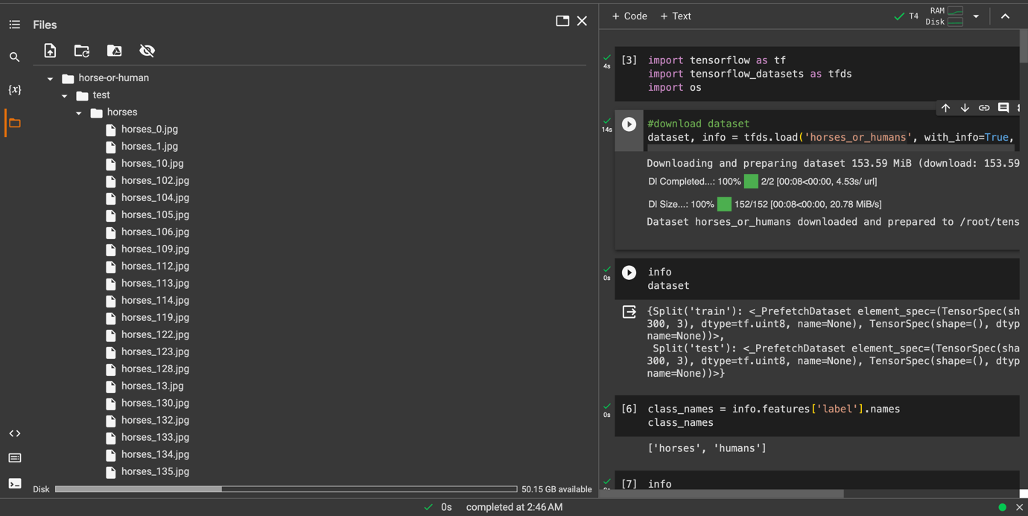

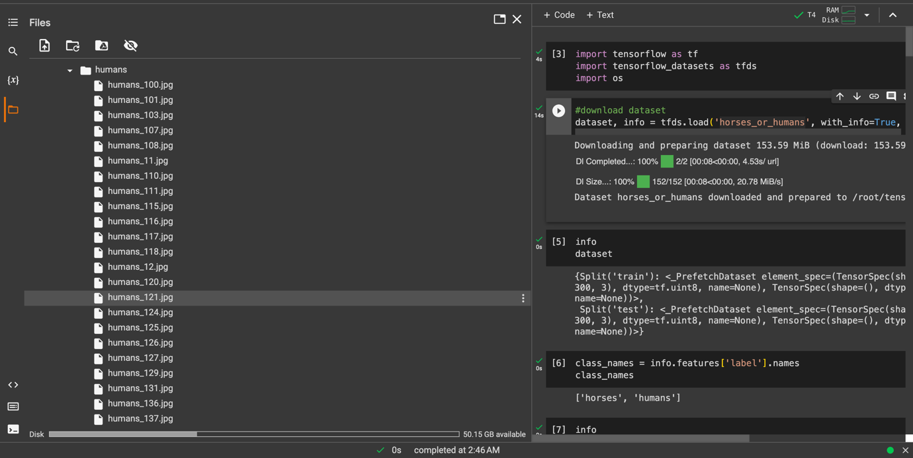





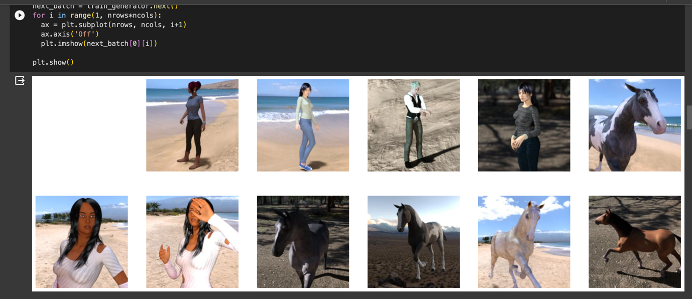

**Appendix B:** Jupyter Data Analysis. Google Collab Data Analysis & Visualization.

JUPYTER IMPLEMENTATION

A)

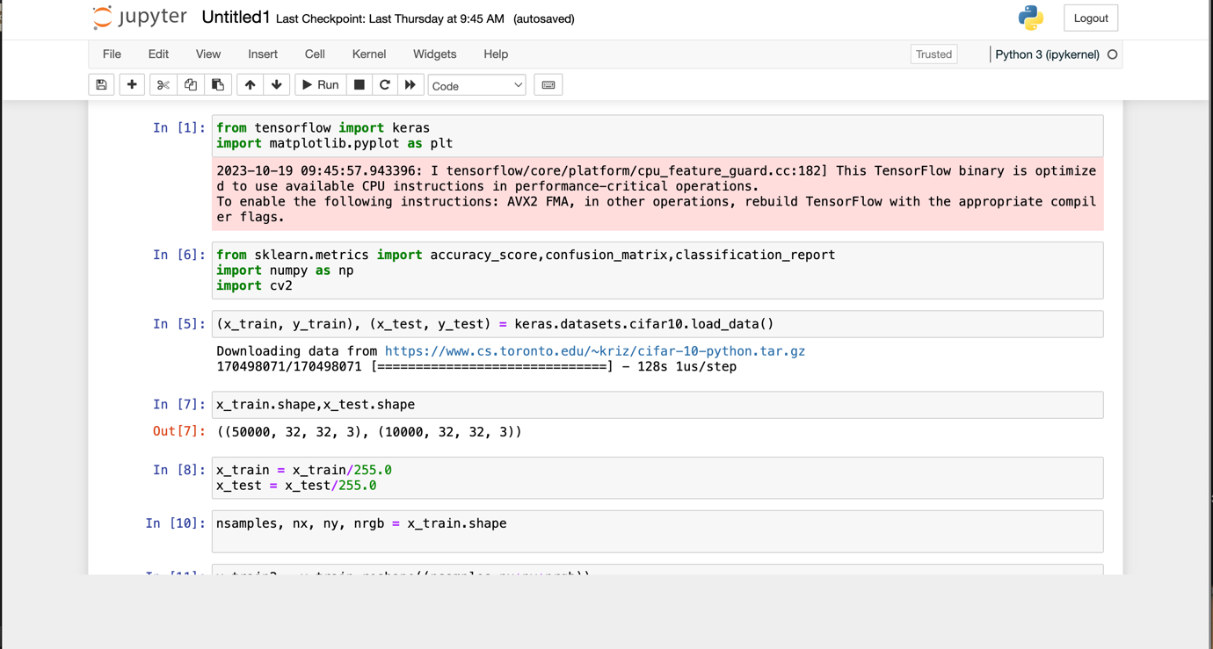

B)

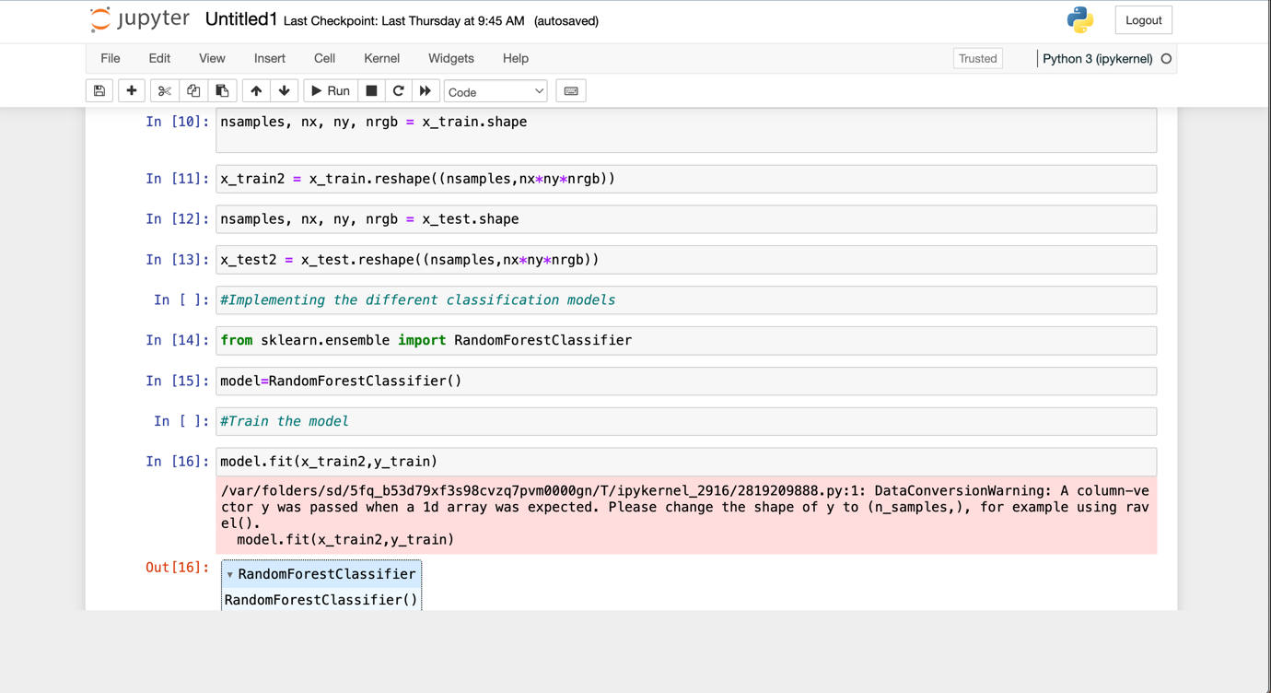

C)

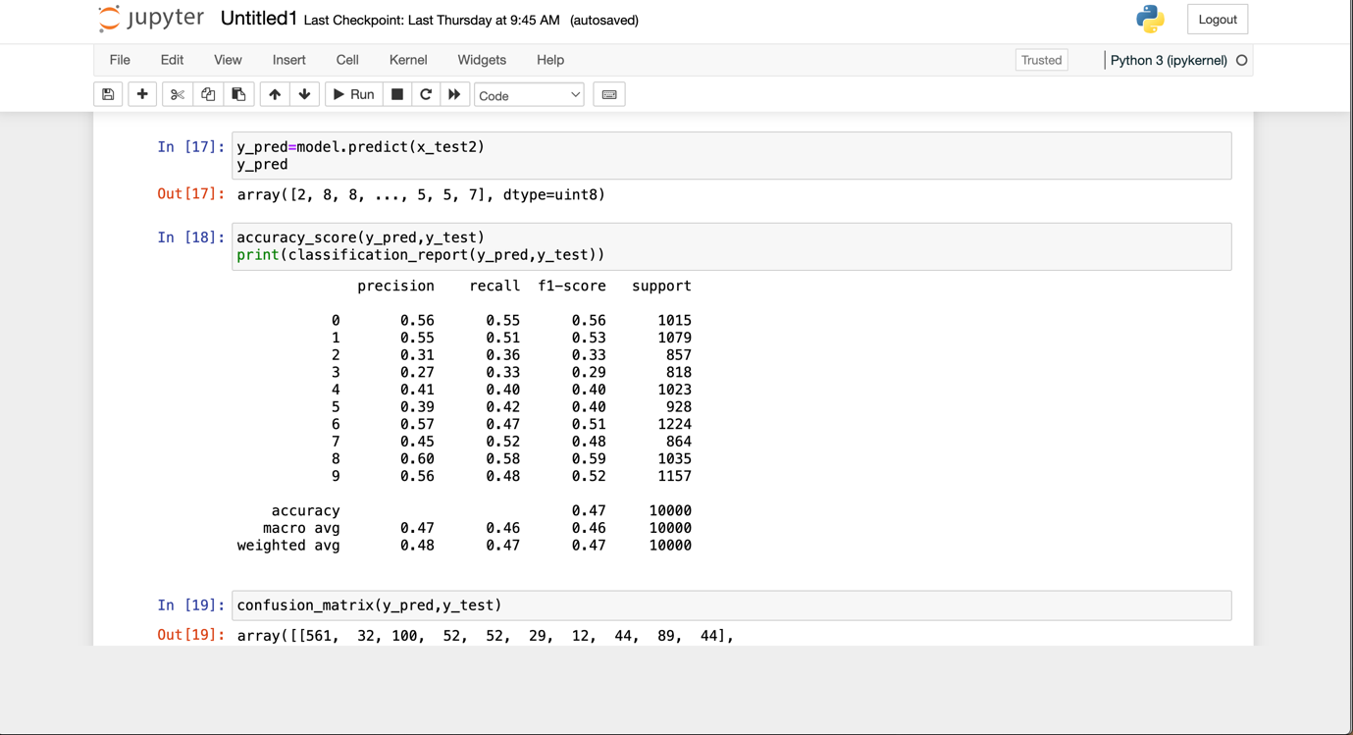

GOOGLE COLLAB IMPLEMENTATION

HORSES VS HUMANS’ DATASET

1. HORSES



1. HUMANS



MACHINE LEARNING ALGORITHMS IMPLEMENTATION FOR IMAGE CASSIFICATION

RANDOM FOREST MACHINE LEARNNG ALGORITHM

A)

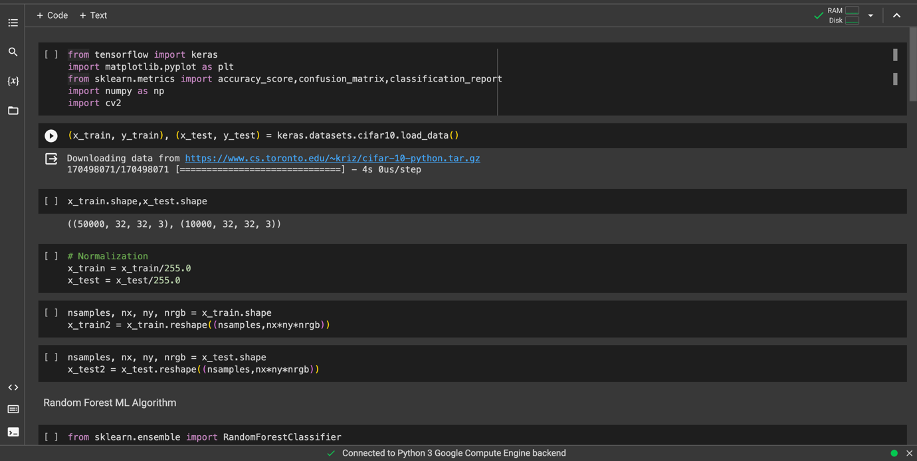

B)

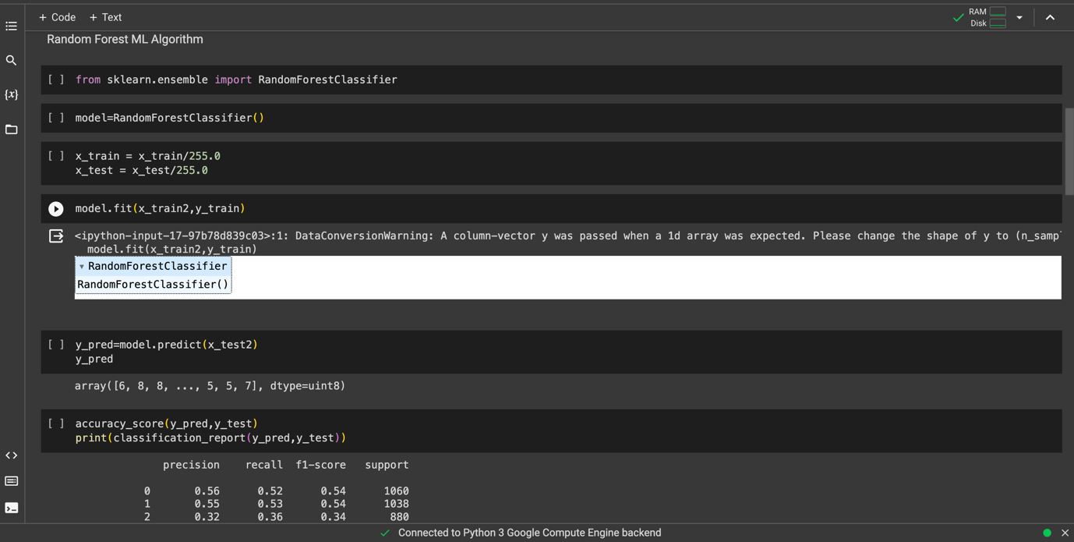

K NEAREST NEIGHBOURS MACHINE LEARNNG ALGORITHM

A)

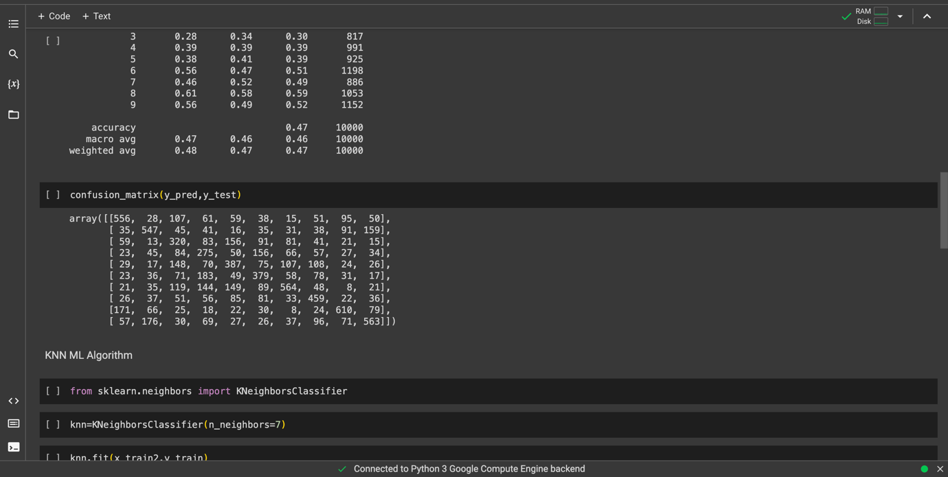

B)

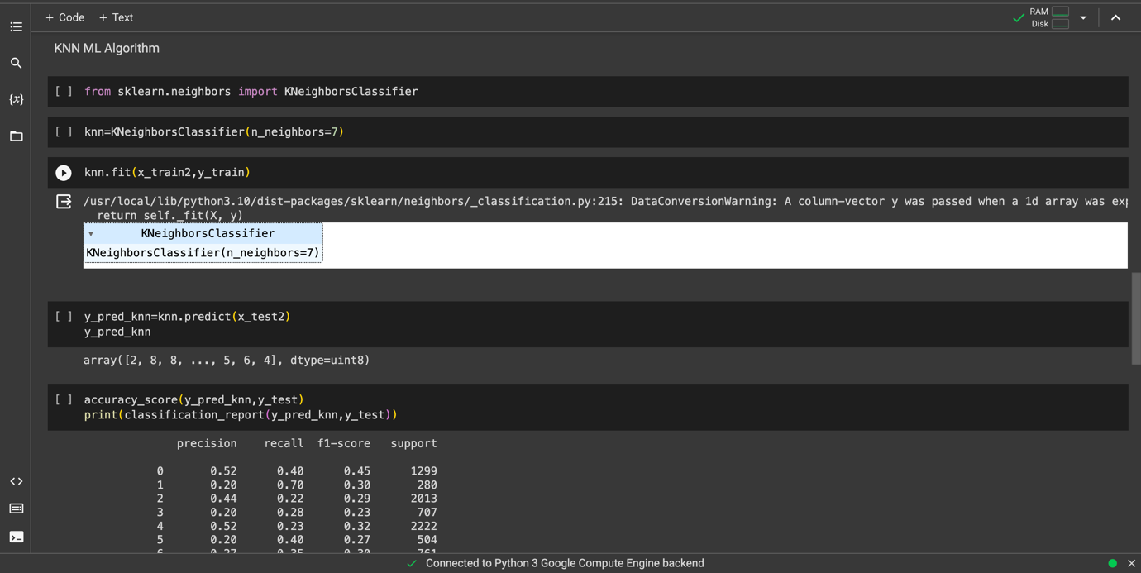

C)

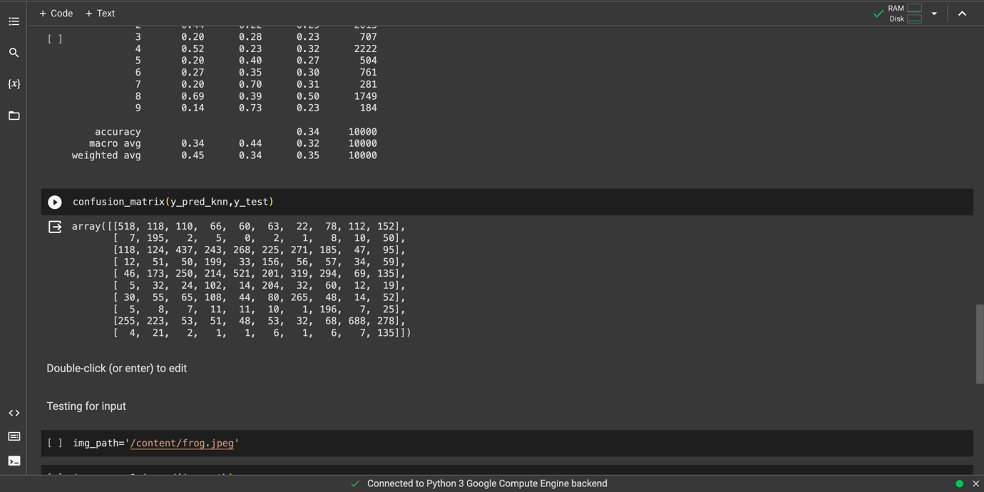

D)

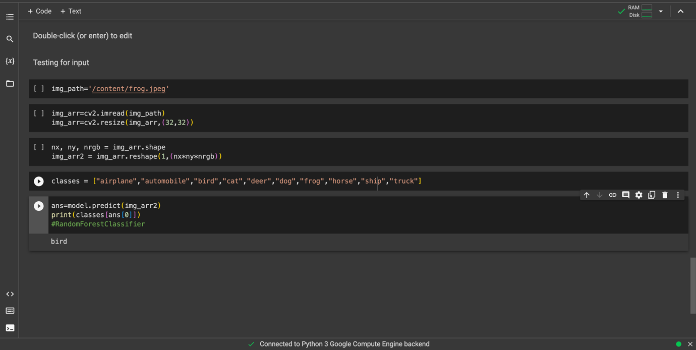

CONVOLUTIONAL NEURAL NETWORK (CNN) MACHINE LEARNING (DEEP LEARNING) ALGORITHM FOR IMAGE CASSIFICATION

A)



B)



C)



D)



E)



F)



G)



H)



I)



J)

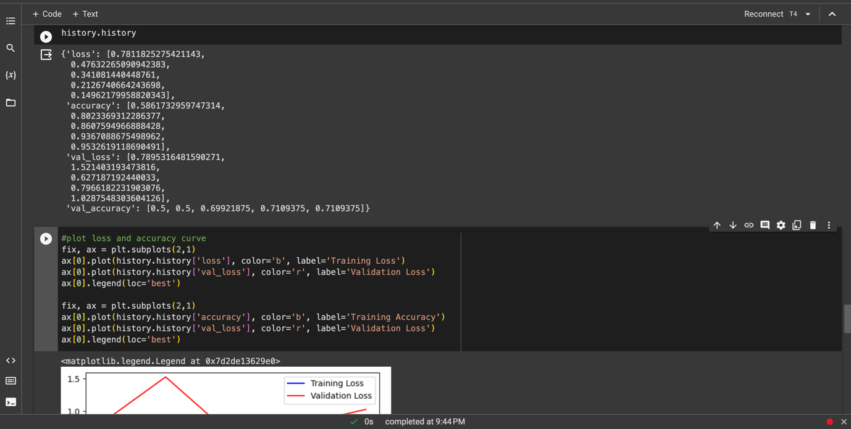

K)



L)



M)



N)

